# ESP32 Cam Project background information

## 

## Table of Contents

**ESP32 Cam Project background information 1**

**Table of Contents 2**

**SDRAM 3**

General Project Structure 4

Case 1: Large data storage 9

Case 2: Instruction memory (and data storage) 13

Case 3: Multi-processor instruction memory 16

**VGA 20**

VGA Timings 20

Our implementation 22

**VGA PLL 24**

**SPI 25**

**ESP-CAM 28**

Hardware setup 28

Software Setup 29

**Accelerometer 31**

Kernels and Filtering 31

Image Convolution 32

Image Blurring 32

Edge Detection 34

**Git 36**

Introduction to Git and GitHub 36

Git Installation and Setup on Your Computer 36

Setting up a Git Repository 39

Basic Git Workflow 43

Branching and Merging 46

The Feature Branch Workflow 49

Code Reviews 51

Handling Conflicts 51

Git Rebase 55

GitHub Features (Issues, releases, tags) 55

README Files 56

Further Resources 56

## 

## SDRAM

SDRAM is an acronym for Synchronous Dynamic Random Access Memory, and the SDRAM functions as the FPGA’s memory module, storing data that the FPGA can access during operation. The DE10-lite boards include a 64MB SDRAM memory chip.

So far, we have used only on-chip memory, which resides inside the FPGA chip itself. This is referred to as SRAM (Static Random Access Memory) and is much faster (and easier to use) than SDRAM. However, there are several reasons we may choose to use the SDRAM over the on-chip memory, including (but not limited to):

1. **Capacity**: On-chip memory is much smaller than SDRAM, meaning we can’t always opt to use it for larger projects.
2. **Cost**: SDRAM chips are relatively inexpensive and thus provide a much higher capacity at a lower cost compared to on-chip SRAM.
3. **Upgradeability**: SDRAM is much cheaper so it can be easily replaced or upgraded for relatively low costs.

The SDRAM controller (in Qsys) handles the complex aspects of accessing SDRAM, such as initialising the memory device, managing SDRAM banks, and decoding memory addresses.

Refer to **Section 33. SDRAM Controller Core** of the [Embedded Peripherals IP user guide](https://drive.google.com/file/d/1epZhX5cBz6iGYJVwu8eBJxNRSIdEWM3n/view?usp=drive_link) for details on the SDRAM's usage, features, and properties in the DE boards' context. If you want to read more about what is involved in controlling the SDRAM chip, you can explore the [**datasheet**](https://www.issi.com/WW/pdf/42-45R-S_86400D-16320D-32160D.pdf) for the SDRAM module.

### 

### General Project Structure

There are many different ways in which you can utilise the SDRAM module in your projects. The below segment details the general steps required to use the SDRAM no matter how you wish to use it, and further down, three different case studies go into further detail on the specific setup required depending on the specific use case. You may find that each use case has overlapping information, but this is there so that each tutorial provides a complete picture.

To allow your project to interface with the SDRAM chip, you must add the “SDRAM Controller Intel FPGA IP” module to your QSYS design and ensure the settings match the following table (Do not touch the “timing” tab). This module handles all of the control signals for the SDRAM chip and gives your NIOS system access to it as a memory-mapped device.

Table 1: SDRAM controller settings

| **Data Width** | |
| --- | --- |
| Bits | 16 |
| **Architecture** | |
| Chip select | 1 |
| Banks | 4 |
| **Address Width** | |
| Row | 13 |
| Column | 10 |

*You can verify these are correct by checking that the stated memory size for the module is “64 MBytes, 33554432 x 16, 512 MBits”. (this can be found at the bottom of the settings window)*

Once the controller has been added to your design, you should set it up like any other memory-mapped device (i.e., the PIO module), and export the “wire” conduit, which will contain all of the SDRAM control signals. The image below shows a **very** basic qsys design where the SDRAM is incorporated as a secondary memory device.

**Note:** for ease of use, you should always lock the base address of the SDRAM controller to be at 0x0.

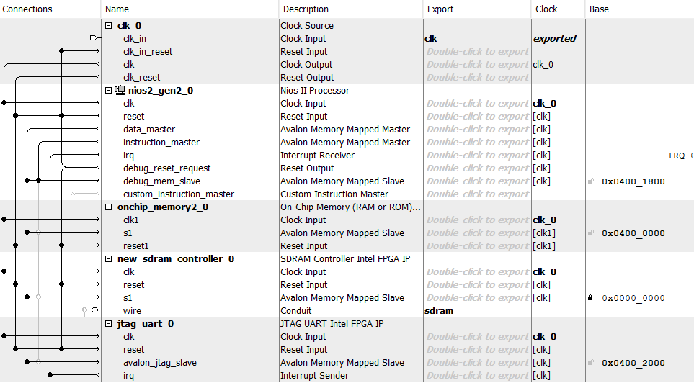

Figure 1: Basic QSYS setup for SDRAM, showing the connection between each module,and exporting the main conduit.

Once you have created the rest of your system in QSYS (like the designs in the three case studies further on) and have generated the HDL for your design, you will need to connect the SDRAM controller to the physical SDRAM chip through your top-level Verilog module.

To connect the QSYS pins to the DE-10 pins, you must first add the pins to the I/O of your top-level module (exactly like every other I/O device). For ease of use, here is a list of pins and types you can copy and paste directly into Quartus.

| // ---- SDRAM IO ---- //  output [12:0] DRAM_ADDR,  output [1:0] DRAM_BA,  output DRAM_CAS_N,  output DRAM_CKE,  output DRAM_CLK,  output DRAM_CS_N,  inout [15:0] DRAM_DQ,  output DRAM_LDQM,  output DRAM_UDQM,  output DRAM_RAS_N,  output DRAM_WE_N, |
| --- |

These pins then directly line up with the output ports on your QSYS design, with the caveat of the LDQM and UDQM pins, which are concatenated together into the sdram_dqm output. The following code snippet shows how this might be set up for a basic Nios system. However, your pin names may vary depending on how you name your modules, so **be careful when you copy/paste**.

| nios_system u0 (  .clk_clk (CLOCK_50),  .reset_reset_n (KEY[0]),  .sdram_addr (DRAM_ADDR),  .sdram_ba (DRAM_BA),  .sdram_cas_n (DRAM_CAS_N),  .sdram_cke (DRAM_CKE),  .sdram_cs_n (DRAM_CS_N),  .sdram_dq (DRAM_DQ),  .sdram_dqm ({DRAM_UDQM, DRAM_LDQM}),  .sdram_ras_n (DRAM_RAS_N),  .sdram_we_n (DRAM_WE_N)  ); |
| --- |

Finally, you must add the Phase-Locked-Loop (PLL) clock to run the SDRAM chip. This clock is still 50MHz (like the rest of the system) but runs 3ns out of phase behind CLOCK_50 so that the SDRAM control signals can propagate to the physical chip before the clock is pulsed.

To add a PLL to your design, open the Quartus IP-Catalog (**not inside platform designer**), search for “pll” and select the module labelled “ALTPLL”. If you are unsure how to use the Quartus IP Catalog, refer to the tutorial in the [ECE3073 Help Manual.docx](https://docs.google.com/document/d/1UIga-ANRF3xXXmVcqP0lVhwvb_lg_cVE/edit#heading=h.7wgun5q7vtt0), Section 3.9.

On the first page of settings, the only change you need to make is to set the input clock frequency to 50MHz (default is 100MHz).

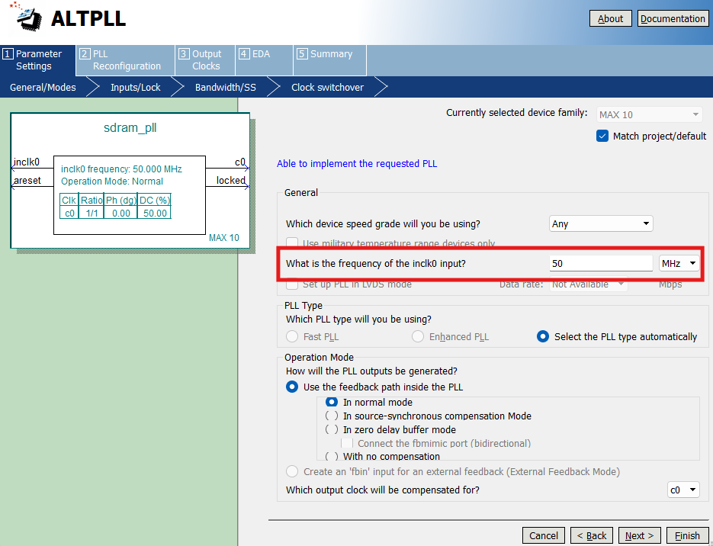

Figure 2: Input frequency settings of the ALTPLL IP module.

On the second page, you can turn off the ‘areset’ and ‘locked’ I/O pins as these are not required. Finally, you do not need to edit any more settings other than the “output clocks” page, where you setup the SDRAM clock parameters. As mentioned earlier, this should be a 50 MHZ clock, with a -3ns phase shift. The settings for this are shown in the image below.

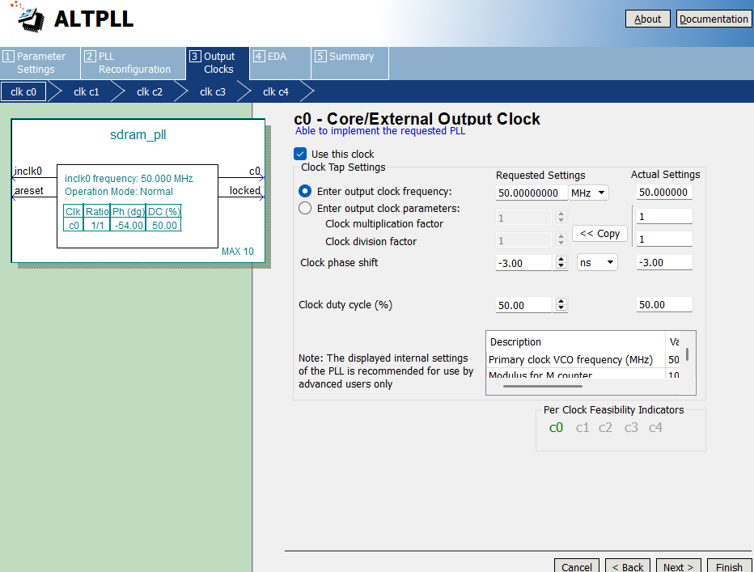

Figure 3: SDRAM clock PLL config settings

To interface with the PLL module, you should look through the Verilog file for the PLL location in the .qip file (as mentioned in the [ECE3073 Help Manual.docx](https://docs.google.com/document/d/1UIga-ANRF3xXXmVcqP0lVhwvb_lg_cVE/edit#heading=h.7wgun5q7vtt0)). As shown in the module I/O Verilog snippet above, the SDRAM clock pin is labelled “DRAM_CLK”.

### 

### Case 1: Large data storage

The most straightforward way to utilise the SDRAM chip on your DE10 is to store large amounts of data, but not for your NIOS processor's instruction/heap memory. In the context of the project, this setup would be beneficial for storing each frame as it arrives over the SPI bus, where it will then be manipulated or displayed as required.

To set up the SDRAM for this simple use case, begin by adding the required modules to your QSYS design as specified in the general instructions earlier in General Project Structure. Then, add your required NIOS processor, on-chip memory, and JTAG-UART module**.** For a barebones system, your QSYS should look something like this:

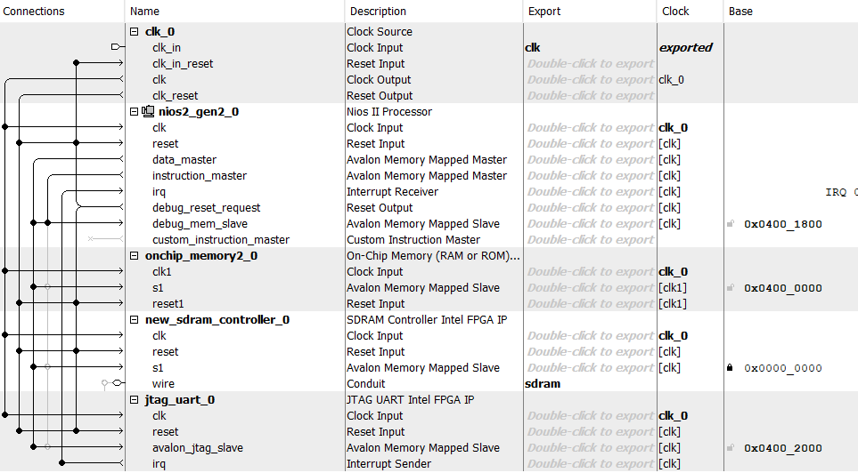

Figure 4: Simple QSYS design for a system that uses the SDRAM as large data storage.

Some things to remember whilst constructing this design are:

* The “Reset Slave” and “Exception Slave” should still be set to your on-chip memory (Under “Vectors” in the NIOS processor settings).
* For ease of use, the SDRAM controller should be locked to the base address of 0x0, and then use “Assign base addresses” as you would normally.
* **Only** the “data master” line is connected to the SDRAM controller, unlike the on-chip memory, which has both the “data master” and the “instruction master”.
* Ensure you have exported the “Conduit” wires from the SDRAM controller. In the image above, it has been exported as *sdram*.

You **must** also add the SDRAM PLL as laid out in the General Project Structure above.

Once synthesised, the following Verilog module (the same as mentioned in the general instructions) connects the QSYS design to the required hardware devices.

| module top_level (  // ---- Generic IO ---- //  input CLOCK_50,    // ---- SDRAM IO ---- //  output [12:0] DRAM_ADDR,  output [1:0] DRAM_BA,  output DRAM_CAS_N,  output DRAM_CKE,  output DRAM_CLK,  output DRAM_CS_N,  inout [15:0] DRAM_DQ,  output DRAM_LDQM,  output DRAM_UDQM,  output DRAM_RAS_N,  output DRAM_WE_N  );  sdram_pll pll0 (  .inclk0(CLOCK_50),  .c0(DRAM_CLK)  )  nios_system u0 (  .clk_clk (CLOCK_50),  .sdram_addr (DRAM_ADDR),  .sdram_ba (DRAM_BA),  .sdram_cas_n (DRAM_CAS_N),  .sdram_cke (DRAM_CKE),  .sdram_cs_n (DRAM_CS_N),  .sdram_dq (DRAM_DQ),  .sdram_dqm ({DRAM_UDQM, DRAM_LDQM}),  .sdram_ras_n (DRAM_RAS_N),  .sdram_we_n (DRAM_WE_N)  );  endmodule |
| --- |

Finally, to ensure there is no memory corruption between the SDRAM and on-chip memory, you must edit the memory configuration of the Nios processor within Eclipse (This step might not be necessary, but you should always check to ensure it is what you expect).

After creating a new project in Eclipse, right-click the BSP folder in the project navigation window on the left, then go “Nios II” > “BSP Editor …”. Inside that window, click on the “linker script” tab, which will lead you to a screen like this:

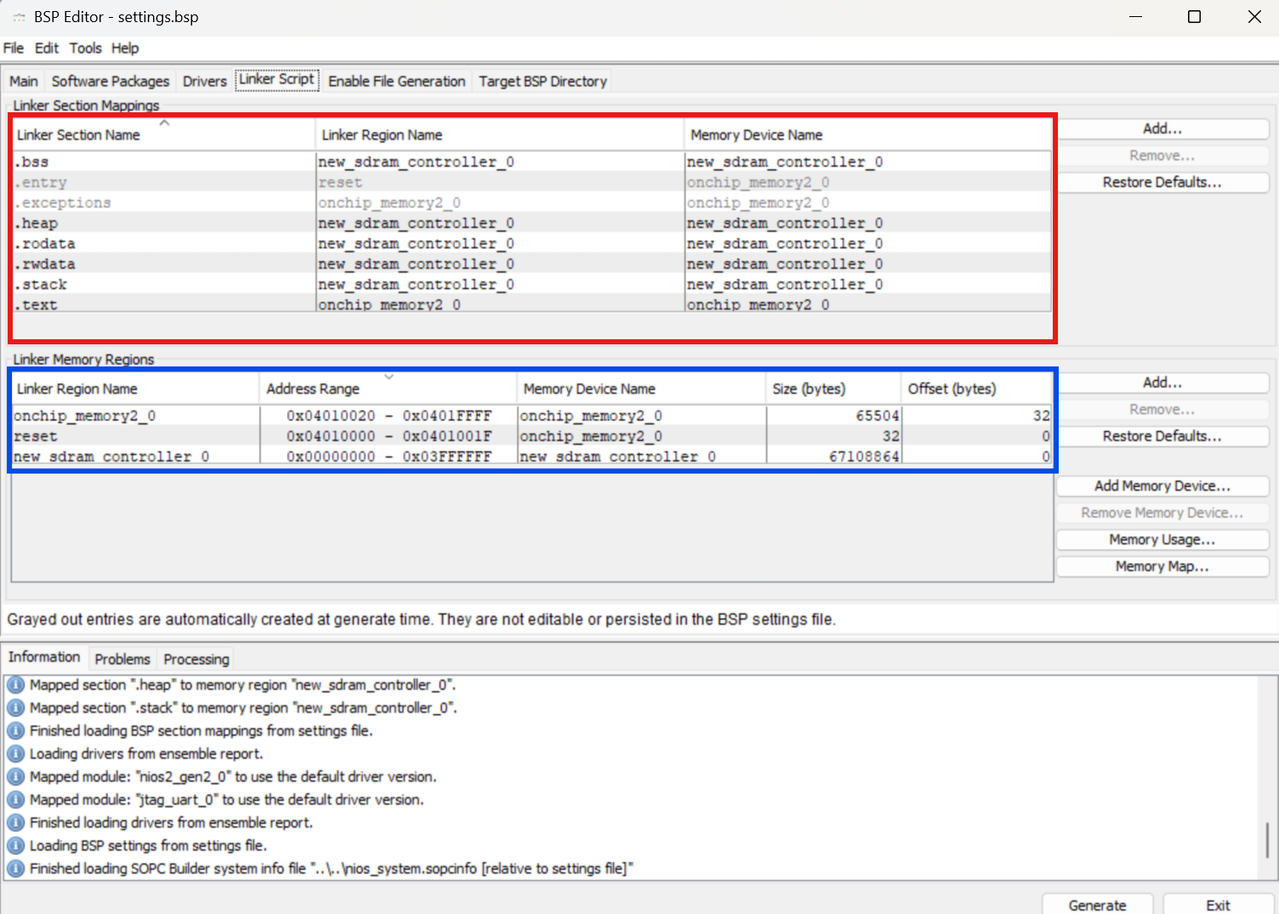

Figure 5: BSP-Editor setup for a project that uses SDRAM as a large data storage device.

The key pieces of information on this screen are:

* [Red, top] A list of each of the critical segments of the processor (stack, text, heap, etc) and the memory device in which they are located
* [Blue, bottom] The name, size, and address space of each memory device available to your Nios processor.

The default setup **should** be as shown above, where the ‘text’ segment is placed on the on-chip memory (this is the instruction information), and the heap/stack memory is placed in the SDRAM. This means that when you create a new array in your code, it will be placed into SDRAM and thus not waste a lot of the sparse memory on the FPGA itself. If your settings match the image above, you do not need to make any changes. If not, make any necessary changes to the “linker region name” column, select generate, and exit the BSP editor. For good measure, you should also manually regenerate the BSP itself by right-clicking the BSP folder and going “Nios II” > “Generate BSP”.

*Note: the names and sizes of each segment may vary depending on your project.*

The setup is now complete. The Nios processor's stack and heap data will be placed into SDRAM. For example, if you are making a buffer for the SPI controller to dump image data into, you would simply create an empty list in your C code. I.e:

char image_buffer[IMAGE_SIZE];

### Case 2: Instruction memory (and data storage)

In cases where there are not enough FPGA memory cells to generate the on-chip memory for our Nios processor, it is possible to set up the SDRAM in such a way that it can store all of the required memory for the processor **and** act as a large storage device for things like video frames from the ESP camera.

To set up the SDRAM for this use case, add the required modules to your QSYS design as specified in the general instructions. Then, add your required NIOS processor and JTAG-UART module (no on-chip memory for this one).For a barebones system, your QSYS should look something like this:

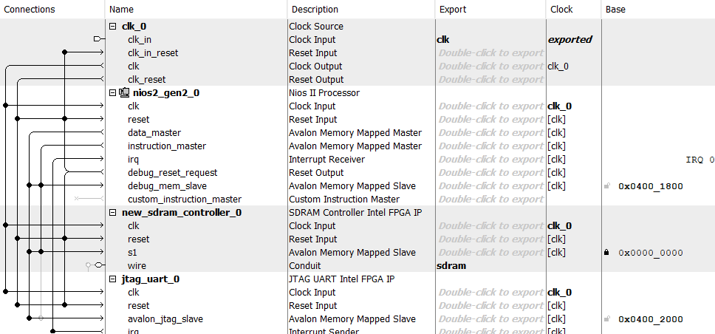

Figure 6: Qsys design for a project with SDRAM for instructions and data storage

Some things to remember whilst constructing this design are:

* The “Reset Slave” and “Exception Slave” should now be set to the SDRAM controller as there is no on-chip memory (Under “Vectors” in the NIOS processor settings).
* For ease of use, the SDRAM controller should be locked to the base address of 0x0, and then use “Assign base addresses” as you would normally.
* **Both** the “data master” and “instruction master” lines should be connected to the SDRAM controller as it will handle both the data and instructions for the Nios processor.
* Ensure you have exported the “Conduit” wires from the SDRAM controller.

You **must** also add the SDRAM PLL as laid out in the General Project Structure above.

Once designed, the following Verilog module (the same as mentioned in the general instructions) would connect the QSYS design to the required hardware devices.

| module top_level (  // ---- Generic IO ---- //  input CLOCK_50,    // ---- SDRAM IO ---- //  output [12:0] DRAM_ADDR,  output [1:0] DRAM_BA,  output DRAM_CAS_N,  output DRAM_CKE,  output DRAM_CLK,  output DRAM_CS_N,  inout [15:0] DRAM_DQ,  output DRAM_LDQM,  output DRAM_UDQM,  output DRAM_RAS_N,  output DRAM_WE_N  );  sdram_pll pll0 (  .inclk0(CLOCK_50),  .c0(DRAM_CLK)  )  nios_system u0 (  .clk_clk (CLOCK_50),  .sdram_addr (DRAM_ADDR),  .sdram_ba (DRAM_BA),  .sdram_cas_n (DRAM_CAS_N),  .sdram_cke (DRAM_CKE),  .sdram_cs_n (DRAM_CS_N),  .sdram_dq (DRAM_DQ),  .sdram_dqm ({DRAM_UDQM, DRAM_LDQM}),  .sdram_ras_n (DRAM_RAS_N),  .sdram_we_n (DRAM_WE_N)  );  endmodule |
| --- |

After creating a new project in Eclipse, right-click the BSP folder in the project navigation window on the left, then go “Nios II” > “BSP Editor …”. Inside that window, click on the “linker script” tab, which will lead you to a screen like this:

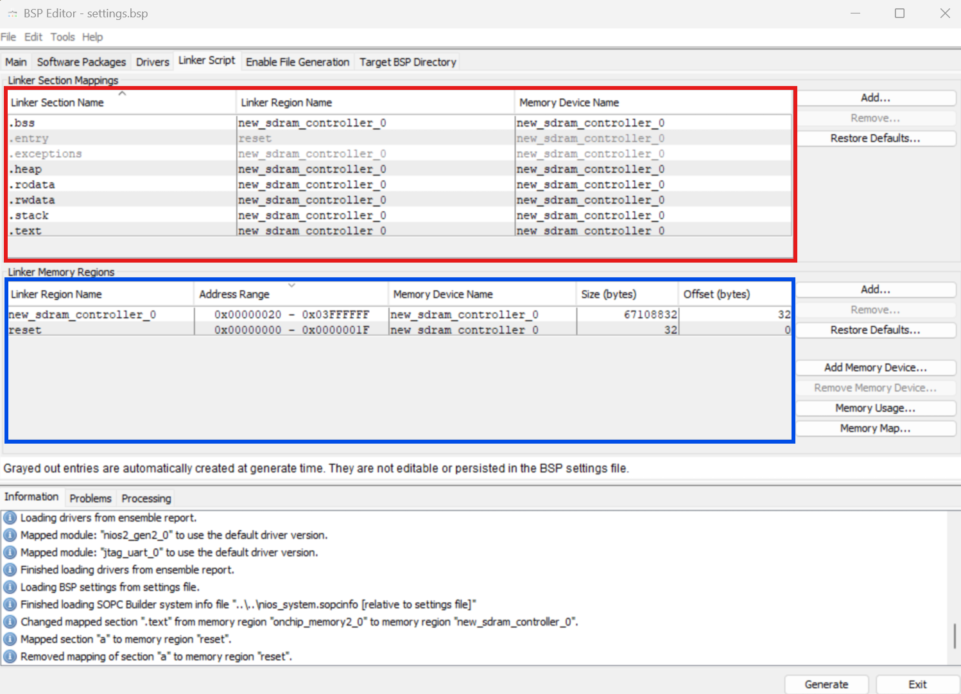

Figure 7: BSP Editor for the system with SDRAM for both instruction and data storage

The key pieces of information on this screen are:

* [Red, top] A list of each of the critical segments of the processor (stack, text, heap, etc) and the memory device in which they are located
* [Blue, bottom] The name, size, and address space of each memory device available to your Nios processor.

The default setup **should** be as shown above, where all memory segments are placed on the SDRAM chip. This means that both the processor's instructions and heap/stack memory will be placed in SDRAM, removing the need for using the FPGA memory cells to fill this role. If your settings match the image above, you do not need to make any changes. If not, make any necessary changes to the “linker region name” column, select generate, and exit the BSP editor. For good measure, you should also manually regenerate the BSP itself by right-clicking the BSP folder and going “Nios II” > “Generate BSP

*Note: the names and sizes of each segment may vary depending on your project.*

The setup is now complete. The Nios processor's instruction memory, as well as the stack and heap data will be placed into SDRAM. For example, if you are making a buffer for the SPI controller to dump image data into, you would simply create an empty list in your C code. I.e.:

char image_buffer[IMAGE_SIZE];

### Case 3: Multi-processor instruction memory

The final and most complicated use case for the onboard SDRAM chip is using it as both the individual instruction and data memory of multiple processors, and a shared memory devices for multiple processors.

As you'll notice in Practical 4 and the project, the DE10's on-chip memory is limited. This becomes an issue when using multiple processors in the same design, as there may not be enough memory to assign to each device. This is where SDRAM comes in—its large capacity allows each processor to have its own enormous section of dedicated memory, which is essential for handling large pixel buffers in the project.

Before continuing, you must have a good idea of how much memory each processor must have. If you do not require shared memory, the easiest way to handle this is to just divide the memory up into even segments. If you require shared memory, you must decide how much memory each processor should have, and then you **leave the shared memory portion unallocated when in the BSP editor.** (will be mentioned later on)

To set up the SDRAM for this use case, add the required modules to your QSYS design as specified in the general instructions. Then, add your required amount of NIOS processors and a JTAG-UART module **for each processor** (no on-chip memory for this example).For a barebones system, your QSYS should look something like this:

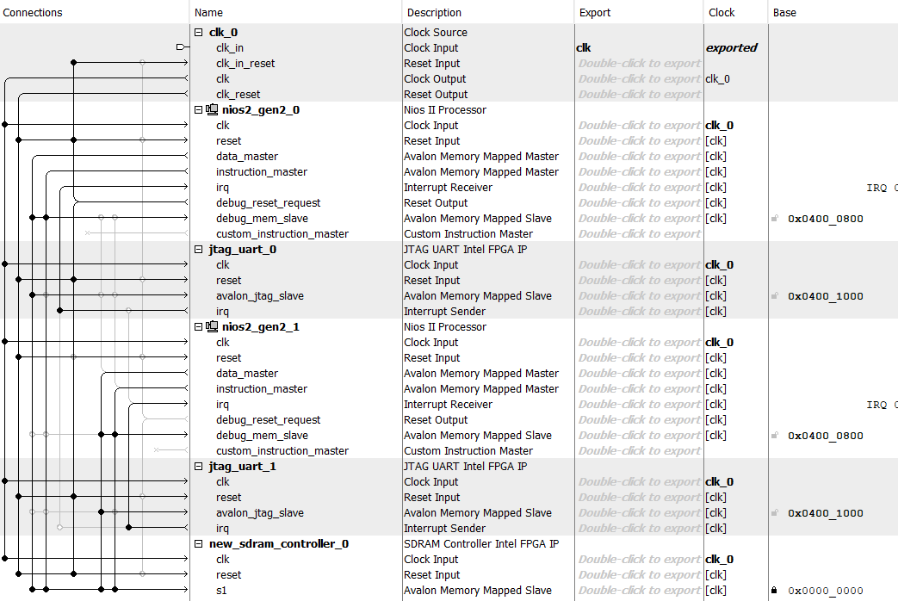

Figure 8: Qsys design for a multi-processor project with SDRAM for instructions and data storage

Some things to remember whilst constructing this design are:

* The “Reset Slave” and “Exception Slave” for each processor must now be set manually. For each processor, the “Reset slave” appears at the very beginning of its allocated memory, and the “Exception slave” appears at an offset of 0x20 words after the reset slave.

For example, if you have two processors and want each one to have 128kB (65,536 words) of memory, you would setup the processors as follows:

* NIOS Processor 1: Starts at 0x0, so the reset is 0x00000000, and the exception slave is 0x00000020.
* NIOS Processor 2: Starts at 0x0 + 0x10000 (65536) = 0x00010000, and the exception slave is at 0x00010020
* For ease of use, the SDRAM controller should be locked to the base address of 0x0, and then use “Assign base addresses” as you would normally.
* **Both** the “data master” and “instruction master” lines for each processor should be connected to the SDRAM controller as it will handle both the data and instructions for the Nios processor.
* Ensure you have exported the “Conduit” wires from the SDRAM controller.

You **must** also add the SDRAM PLL as laid out in the General Project Structure above.

Once designed, the following Verilog module (the same as mentioned in the general instructions) would connect the QSYS design to the required hardware devices.

| module top_level (  // ---- Generic IO ---- //  input CLOCK_50,    // ---- SDRAM IO ---- //  output [12:0] DRAM_ADDR,  output [1:0] DRAM_BA,  output DRAM_CAS_N,  output DRAM_CKE,  output DRAM_CLK,  output DRAM_CS_N,  inout [15:0] DRAM_DQ,  output DRAM_LDQM,  output DRAM_UDQM,  output DRAM_RAS_N,  output DRAM_WE_N  );  sdram_pll pll0 (  .inclk0(CLOCK_50),  .c0(DRAM_CLK)  )  nios_system u0 (  .clk_clk (CLOCK_50),  .sdram_addr (DRAM_ADDR),  .sdram_ba (DRAM_BA),  .sdram_cas_n (DRAM_CAS_N),  .sdram_cke (DRAM_CKE),  .sdram_cs_n (DRAM_CS_N),  .sdram_dq (DRAM_DQ),  .sdram_dqm ({DRAM_UDQM, DRAM_LDQM}),  .sdram_ras_n (DRAM_RAS_N),  .sdram_we_n (DRAM_WE_N)  );  endmodule |
| --- |

After creating a new project in Eclipse, right-click the BSP folder in the project navigation window on the left, then go “Nios II” > “BSP Editor …”. Inside that window, click on the “linker script” tab, which will lead you to a screen like this:

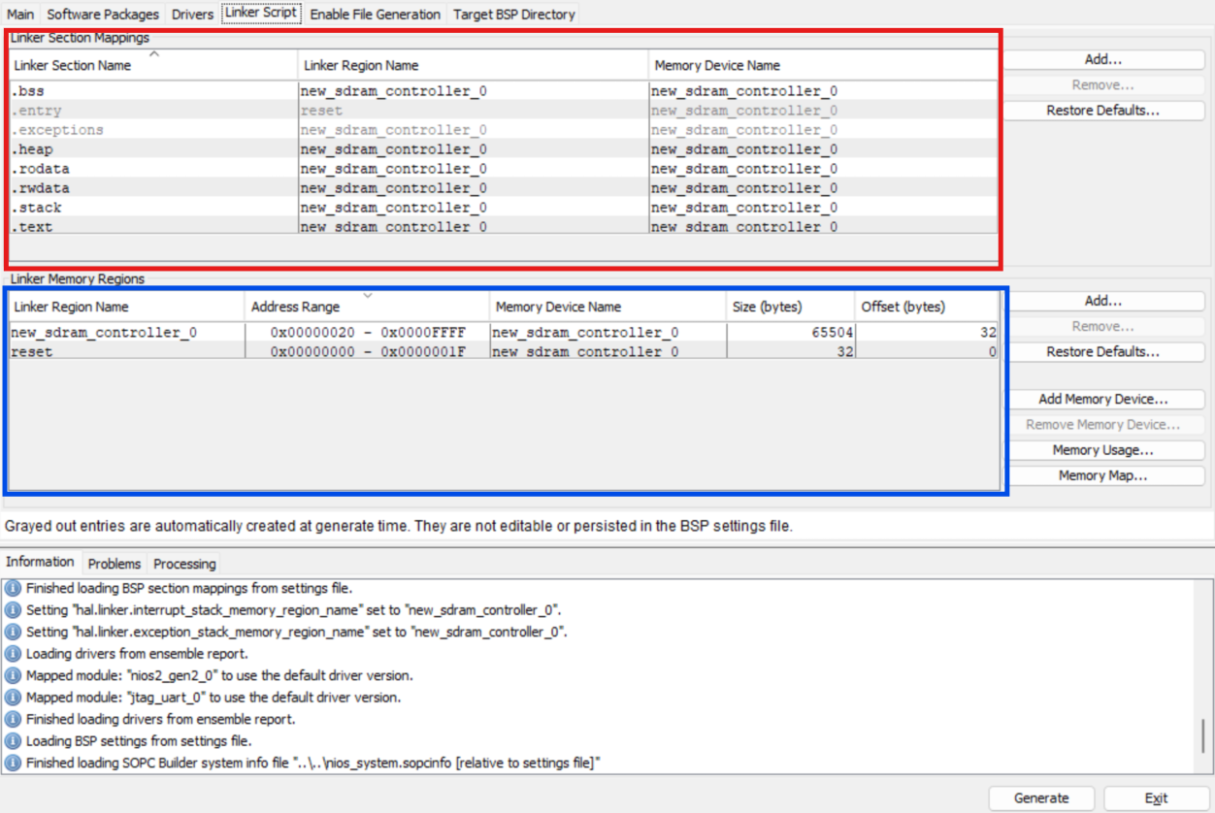

The key pieces of information on this screen are:

* [Red, top] A list of each of the critical segments of the processor (stack, text, heap, etc) and the memory device in which they are located
* [Blue, bottom] The name, size, and address space of each memory device available to your Nios processor.

The setup for this multi-processor example is more complex than in previous projects. When configuring it, you should only need to edit the Blue/Bottom section of the BSP Editor window. For each NIOS processor, the region sizes are based on the reset vectors you defined in QSYS. The reset offset and size will be set automatically for each processor, and for all but the last processor, the SDRAM offset and size will be automatically configured as well. For the last processor (the one furthest along the memory address space), you'll need to manually adjust the SDRAM memory size to your desired value, keeping in mind that any unused memory can be allocated as shared memory. After making these changes, select 'Generate' and exit the BSP Editor. For good measure, you should also manually regenerate the BSP by right-clicking the BSP folder and selecting 'Nios II' > 'Generate BSP'.

*Note: the names and sizes of each segment may vary depending on your project.*

The setup is now complete. The Nios processor's instruction memory, as well as the stack and heap data will be placed into SDRAM. For example, if you are making a buffer for the SPI controller to dump image data into, you would simply create an empty list in your C code. I.e.:

char image_buffer[IMAGE_SIZE];

To access any of theunallocated shared memory, you can use the IO read/write commands which have been explained in the practicals. **Since this memory is unallocated, you must keep track of these addresses yourself to ensure you do not overwrite the individual processor memory.**

# 

## VGA

As you may have noticed, one of the ports on your DE10-Lite is a VGA port. The VGA or Video-Graphics-Array protocol is an analog display technique that was the international standard for displaying images from the 1980s up until the 2010s.

You do not need to understand the in-depth workings of VGA because we provide you with a module that does most of the alignment and calculations for you, but it's important that you have a general idea of how it works so that you can better debug your code and potentially make improvements to the display features in the future.

### VGA Timings

Old CRT monitors used an electron beam to blast pixels onto the screen line by line[1]. The “ray” would start in the top-left corner, and go from left to right, top to bottom. At the end of each row, the electron beam would need time to slow down before it moved down to the next row. Since VGA was originally made for these monitors, the porches are margins around the visible area where the pixels written are inconsequential as they acted as a sort of runway.

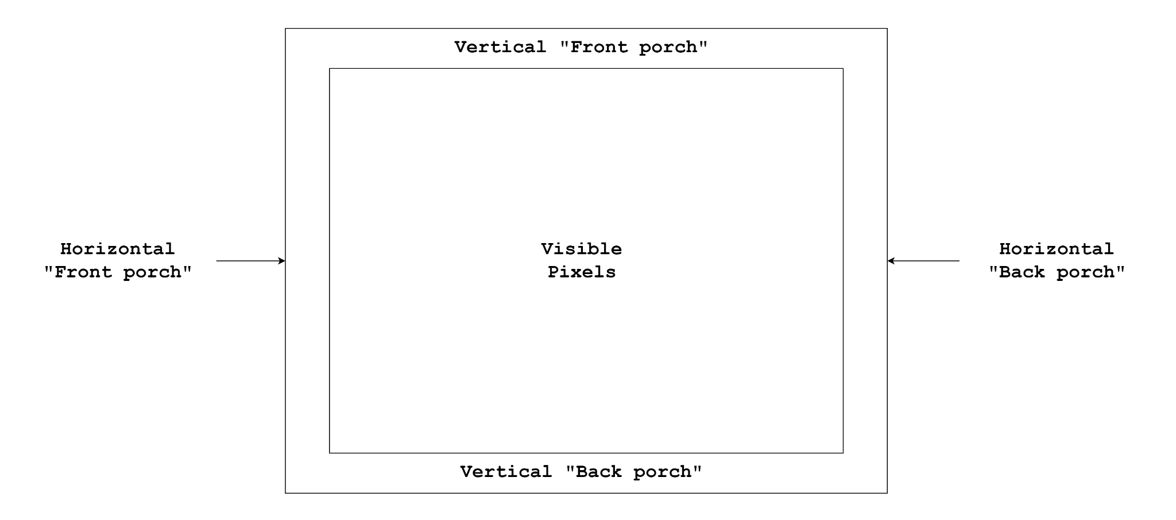

**Figure 1:** Diagram of VGA “porches”

To ensure each pixel is aligned in the correct position (porch, visible, etc), there is a separate “sync” signal that is sent to the monitor for both vertical and horizontal “syncing”. When the sync pulse is sent, the monitor would know that the current pixel is at the beginning of the respective “front porch” (either horizontal or vertical), and then the length (amount of pixels) of the pulse would determine the current resolution.

In modern-day hardware, two of the pins on the VGA port act as an I2C bus that allows the monitor to send the graphics driver what resolutions it supports. Since we are only using a very rudimentary VGA port with only 5 pins (see below), we cannot get this information from the monitors, so we are going to use the industry standard which is 640 x 480 pixels at 60 Hz (FPS). The specifications of this resolution can be found below (**Table 1**)

**Table 1:** [VGA Standards](http://tinyvga.com/vga-timing) for the 640 x 480 resolution.

| **Resolution** | **Horizontal Visible Pixels** | **Horizontal Total Pixels** | **Vertical Visible Pixels** | **Vertical Total Pixels** | **Clock Speeds(MHz)** | **Frames per second (FPS)** |
| --- | --- | --- | --- | --- | --- | --- |
| 640 x 480 | 640 | 800 | 480 | 525 | 25.175 | 59.95 |

You can learn more about the exact timing of these signals [**here**](https://www.youtube.com/watch?v=l7rce6IQDWs).

As mentioned earlier and seen below (Figure 3), the DE10 VGA port has 5 main data-carrying pins:

* VGA_R: an **analog** voltage that represents the intensity of red in the current pixel
* VGA_G: an **analog** voltage that represents the intensity of green in the current pixel
* VGA_B: an **analog** voltage that represents the intensity of blue in the current pixel.
* VGA_HS: a **digital** signal that represents the beginning of a horizontal line (Horizontal Sync)
* VGA_VS: a **digital** signal that represents the beginning of a vertical line. (Vertical Sync)

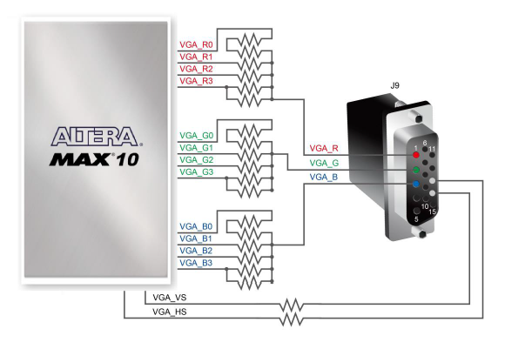

**Figure 2:** DE-10 on-board VGA hardware [1]

### Our implementation

To aid with your project, you should read the pre-written VGA controller module, “vga_controller.v” in the [Project-Templates](https://github.com/ece3073-monash/project-templates) repository. This module will handle the porches and timing information of the VGA controller. You will utilise the controller by reading the address of the current pixel being displayed and writing the 4-bit greyscale value of the pixel corresponding to that address. The “address” of each pixel is simply a linearised index of the current row and column. It is calculated using the following formula:

$Address = Column + (Row ⋅Width)$

Due to some hardware limitations on the DE boards, the images displayed will only be 320 * 240 pixels. This means the number of pixels stored will only be ¼ of the original size (640 * 480). However, when displaying the images, we need to re-scale back up to 640 * 480, which means the pixel in each memory address will be copied 4 times (2 times across, 2 times down). Figure 3 shows a 64-pixel square of the base 640 * 480 image (left side), and how each pixel of the downscaled image (right side) will be duplicated into 4 of the full-scale pixels. Figure 4 shows how the pixels are stored in memory before being displayed through the VGA.

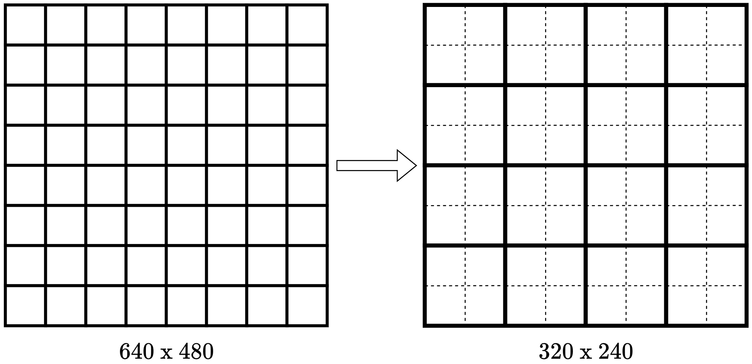

**Figure 3**: Pixel Downscaling

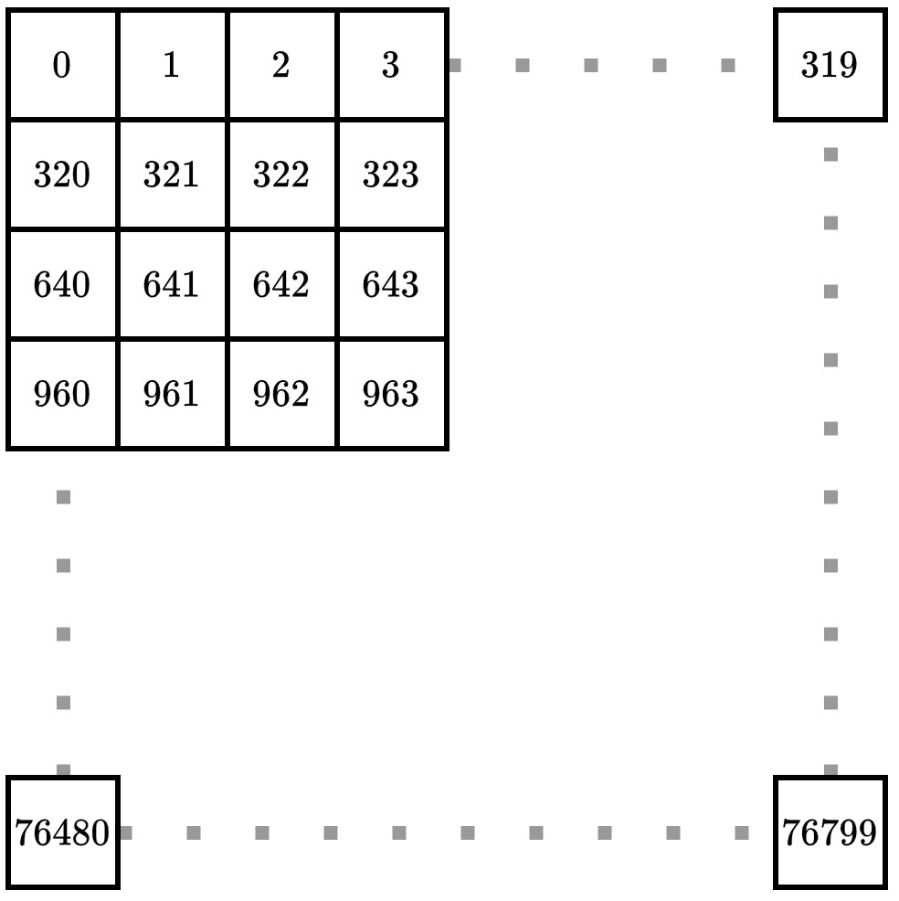

**Figure 4:** Address Visualization

### 

# 

## VGA PLL

To get the VGA Controller working, you will also need to add something called a “PLL” or Phase-locked loop module. You might learn about how these work in other units, but for now all you need to know is that they are a piece of analog hardware that can take in one clock signal (e.g. CLOCK_50 from your FPGA), and split it up into multiple clock signals with varying speeds and phases. The DE-10 board you are familiar with contains 4 PLLs which can each output 4 different clock signals.

As you will have read, the VGA controller requires a 25 MHz clock. However, since your board operates on a 50 MHz clock, we will need to utilize the PLL to generate it.

From the [intel IP-Catalog](https://docs.google.com/document/d/1zSjIu7TljbZ4HU-d4H-HNsEtCFrj57S3/edit#heading=h.7wgun5q7vtt0), create an “ALTPLL” module with the following settings

* Input frequency on the first page (set to 50MHz)
* Turn off all additional inputs and outputs on the second page (i.e “areset” and “locked”)
* Go forward a few pages until “c0 - Core/External Output clock”.
  + Tick the box that says “use this clock”
  + This clock should be a 25 MHz clock with no phase shift and a 50% duty cycle.
* Select “finish”

The c0 output port is the clock that you will use as the VGA clock, which will be used to read and write from the pixel buffer.

## SPI

**S**erial **P**eripheral **I**nterface (**SPI**) is a hardware layer protocol typically used in embedded systems for **short-distance** communication. SPI defines how bits are transferred between devices but not what they mean, giving a lot of flexibility in what data/protocols can be used over it.

SPI is a “bussing protocol”, meaning it is designed to facilitate communication between one controller to one or many peripherals. It is typically used in a 4-wire configuration that allows full duplex (can transmit in both directions simultaneously) communication between the controller and one peripheral at a time. However, it is possible to broadcast one way to multiple devices in some contexts.

The four wires that make up an SPI connection are:

* **SPI Clock**: The clock that controls data transfer for all devices, the SPI clock will always be controlled by the controlling device.
* **Controller to Peripheral Data:** The wire responsible for carrying data from the controlling device to the peripheral device that is currently selected.
* **Peripheral to Controller Data**: The wire responsible for carrying data from the currently selected peripheral device to the controlling device.
* **Peripheral Chip Select**: A (typically) one-hot coded select line that indicates which peripheral device is currently selected for sending or receiving data.

A typical SPI configuration can be seen in the diagram below:

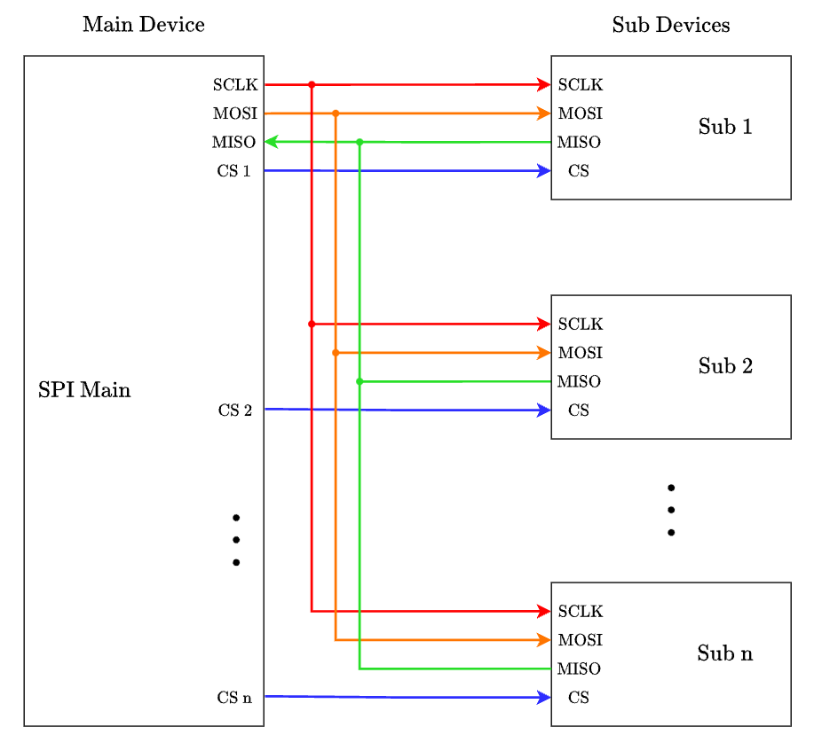

In the past, the SPI protocol standard used the terms “Master” and “Slave” for the controller and peripheral devices, respectively. However, after a fairly [recent change](https://www.oshwa.org/a-resolution-to-redefine-spi-signal-names/), a wide range of alternative terminologies have been adopted by each organisation, with a much less standardised approach.

The four SPI wires also have a set of widely used abbreviations/acronyms to easily label their purpose. However, these names can vary depending on how the controller and peripheral devices are labelled. For example, the original names are as follows (but have since been changed):

* SPI Clock: **SCLK**
* Controller to Peripheral Data: **M**aster **O**ut **S**lave **I**n (**MOSI**)
* Peripheral to Controller Data: **M**aster **I**n **S**lave **O**ut (**MISO**)
* Peripheral Chip Select: **CS**

The terminology you will see in this unit is summarised below:

| **Controller Name** | **Peripheral Name** | **Wire Names** | **Context** |
| --- | --- | --- | --- |
| Master | Slave | MOSI / MISO | Outdated terminology. However, SPI is so widely used that it will take time to fully convert all documents/software. You will see this terminology when using Quartus and any IP related to the SPI hardware. |
| Main | Sub | MOSI / MISO | Common replacement for Master and Slave as it maintains the traditional wire names. |
| Host | Agent | HOAI / AOHI (useless) | The SPI naming used in the Intel SPI controller documentation (even though Quartus still has MOSI/MISO). |
| Controller | Peripheral | POCI / PICO | A fairly popular renaming of the SPI devices that you will likely come across in your own research. |

**Project M1’s document goes through partial instructions on setting up SPI on the DE10.**

In SPI all communication is controlled by the Controller through the use of the Clock and Chip Select lines. When communicating, the controller will first activate the chip select line (typically active low) for the peripheral that it wants to talk to and will then send a clock signal on the clock line to indicate when to read and send data. The Controller will send its data on the MOSI line and at the same time the peripheral will send its data on the MISO line.

The default state of the clock line when there is no transmission is known as the **Clock Polarity**, and which clock edge (moving from or to its idle state) the data is read on is known as the **Clock Phase**. A combination of a Polarity and Phase is a **Mode**, as there are 4 combinations of Polarity and Phase there are 4 [SPI Modes](https://en.wikipedia.org/wiki/Serial_Peripheral_Interface#Mode_numbers). Some devices can only operate in one mode (like the Gyro on the DE10), some have limitations on what they can do and speeds they can run at in different modes, and some can run in whatever mode you like. Which mode you use will likely be defined by a device on the bus that can only operate in one mode. This also means that sometimes if two devices can not operate in the same mode, then they can not be on the same bus; for this reason, typically controllers will let you select their mode so that they can talk to whatever device you may want to connect to.

## ESP-CAM

**Note:** There will never be a scenario in which you must program the ESP-CAM board yourself. If you believe there is an issue with the camera, let a demonstrator know or make a post on ED detailing your issues.

### Hardware setup

The interface board attached to the ESP-CAM allows you to easily plug the camera straight into the GPIO port on your DE10. The 6x2 connection should be seated at the very top left (USB port side) of the GPIO connector, with the camera facing away from the DE10, as depicted in the image below.

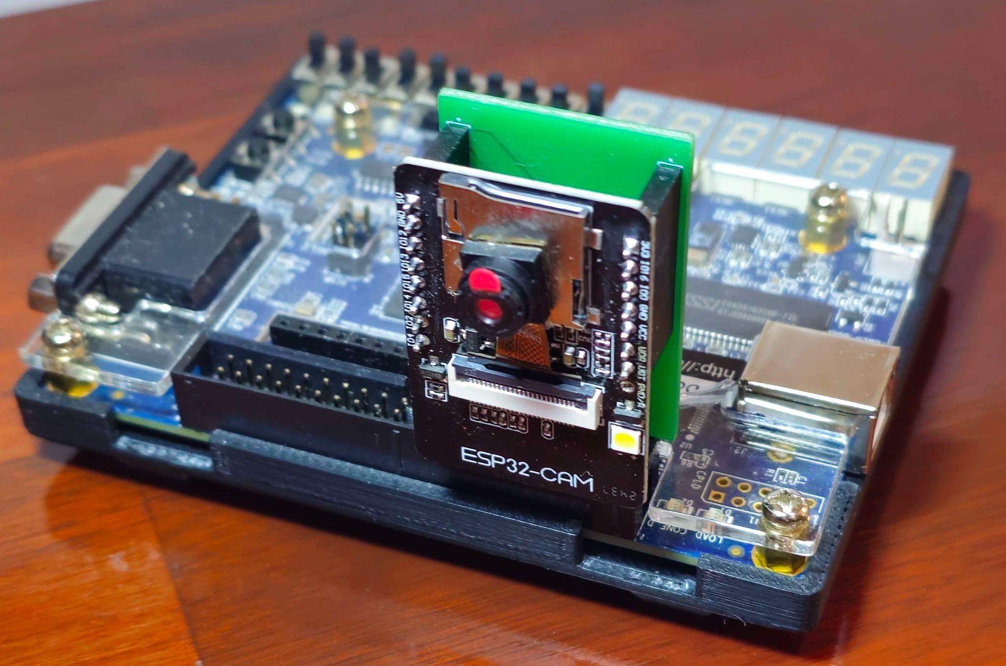

The ESP-CAM has five output pins that you will need to interface with:

* **SPI_SDO:** The SDO pin (Serial Data Out) should be connected to the SPI wire that handles data input into the DE10.
* **SPI_SDI:** The SDI pin (Serial Data In) should be connected to the SPI wire that handles data input into the ESP-CAM.
* **SPI_SCLK:** The clock that controls the SPI communication.
* **SPI_CS_N:** This is the active low chip select pin for the camera.
* **CAM_READY:** This is an input to the DE10 that will go high whenever the camera has a frame in its buffer that is ready to be sent.

The following table shows the mapping between the ESP-Cam pins and the DE-10 board. There are also voltage and ground pins connected, so ensure the board is plugged into the correct position.

| **ESP-CAM Pins** | **DE-10 GPIO Pins** |
| --- | --- |
| **SPI_SDO** | **GPIO[7]** |
| **SPI_SDI** | **GPIO[8]** |
| **SPI_SCLK** | **GPIO[9]** |
| **SPI_CS_N** | **GPIO[5]** |
| **CAM_READY** | **GPIO[2]** |

**To avoid unexpected behaviour when interfacing with the ESP-CAM, you MUST set the unused GPIO pins to be a high-impedance output by assigning them to the binary value of ‘z’. i.e. assign GPIO[11:9] = 3’bzzz;**

### Software Setup

The image data on the ESP-CAM will be accessed through the ‘alt_avalon_spi_command()’ function (as detailed in the [M1 document](https://docs.google.com/document/d/1dCBVDn1swcVkEB9k41yAv5fwvRmAM_QDuVHKTNi9dGI/edit?tab=t.0#heading=h.3vyuijixw7yl)). This function requires **both** an input and output buffer to be specified. This means that to get information from the ESP-CAM, you must first send it something yourself. The camera has been set up in such a way that you will send it a single byte of data, where each bit will represent a setting that you can change, and it will respond with a single frame of the video feed after having applied the settings you provided. Note that the raw data coming from the ESP-CAM needs to be shifted right 4 bits.

For milestone 1, you should only send the camera a byte of all 0’s (0x0 will do) so that it is using the default settings. For later tasks, however, the following settings can be applied (from LSB to MSB). **Note:** The ESP cam will not register any settings unless Bit 4 is set:

* Bit 0: Greyscale image [0] / 4-bit RGB image [1]
* Bit 1: 320x240 image [0] / 160x120 image [1]
* Bit 2: Raw data stream [0] / Packed data stream [1]
* Bit 3: Flash LED off [0] / Flash LED on [1]
* Bit 4: No changes [0] / Changes in setting [1].

The following information refers to how the pixel data is packed and transferred across the SPI bus.

* **Raw data mode (Bit 2 = 0):**
  + When the camera is in **greyscale** mode, each pixel is sent as a single byte. However, only the **top 4 bits** are used, meaning if your buffer is an 8-bit data type, you will have to shift the data to the lower 4 bits for it to be useful.

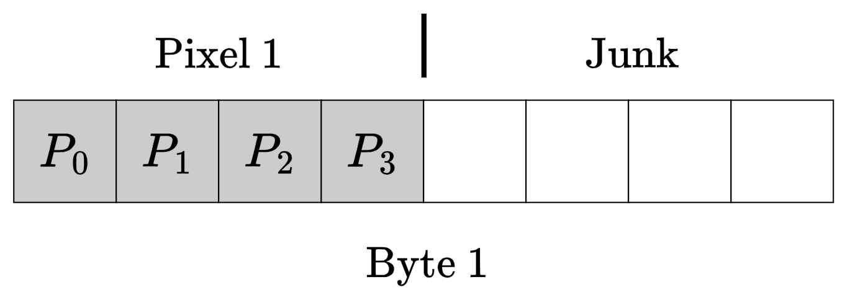

* + When the camera is in **RGB** mode, each pixel is sent as two bytes where the data is organised in a “5-6-5”, meaning there are 5 red bits, 6 green bits and 5 blue bits. It is up to you to load this pixel data into an appropriate data type and to format it into 4-4-4 to be used by the VGA controller.



* **Packed data stream (Bit 2 = 1):** 
  + When the camera is in **greyscale** mode, each pixel will now be sent in groups of two so that for each byte transferred, the top 4 bits are for one pixel, and the bottom 4 bits are for another.

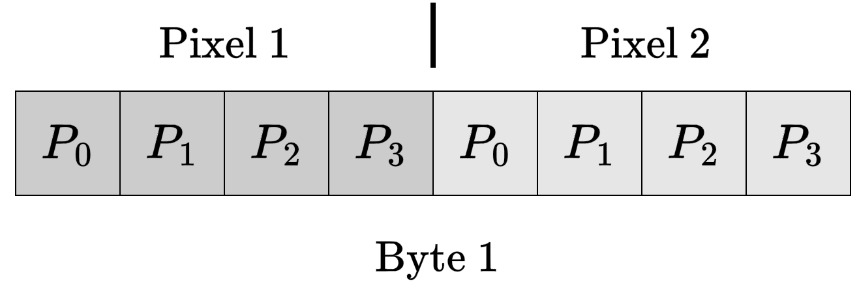

* + When the camera is in **RGB** mode, each pixel will be sent in a group of two pixels occupying 3 bytes. The data in this mode is organised into a “4-4-4” format, meaning each pixel is 12 bits long.

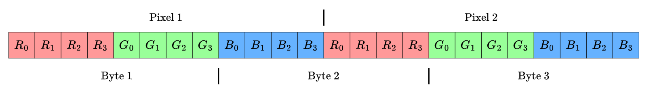

## Accelerometer

As well as the standard I/O that you have become familiar with on the DE10s (Switch, Keys, Hex displays, etc.), you can also find a gyroscopic sensor or “accelerometer”. An accelerometer is a sensor that can measure the acceleration of motion to determine both its rotation/position, and the vibrations in the surrounding environment. This specific model can be interfaced with using either I2C or SPI, but we will only be using SPI in this unit.

Most of the content in this section is covered in the week 4 workshop. If you find yourself struggling with this content, it is strongly recommended that you watch the recording of this session and follow along with the simple accelerometer example.

The primary method of sending data to/from the accelerometer is through a large bank of addressable registers, which will contain all of the programmable settings, as well as all output data from the sensor itself. In terms of SPI, the accelerometer splits each transfer up into groups of two bytes, where the first byte of the message is the address of the register you wish to access, and the second byte is the data you wish to place into that specific register (in a write transaction).

All information regarding register addresses and values, along with how to set up and service interrupts for the accelerometer, can be found on the datasheet.

**Note:** The accelerometer itself has interrupt settings as well as the PIO register that the ‘int’ pin connects to. You must initialise, clear and handle **both** sets of interrupts when using the tapping functionality.

## Kernels and Filtering

### Image Convolution

Convolution is the process of moving through an image in a [**raster-scan**](https://www.ntsc-tv.com/images/tv/aa-raster-1.gif) order and applying a function to pixels within a region/kernel. As you can see from the link above, raster-scan is the process of moving one pixel at a time along the row of the image from left to right. Once we get to the end of the row, we start from the next row and repeat the same process as above. When we move one pixel at a time, we can look into the value of that pixel as well as surrounding ones and perform some sort of operation on them. These operations could be such as blurring the image through averaging the centre pixel and pixels around it (a kernel), or by applying a set of values on the kernel itself.

### Image Blurring

Blurring an image is one of the most basic operations in image processing. It has been performed since the day of old-school cameras by manipulating the focal length and changing the focus in an image. Blurring an image has many uses, such as:

1. Reducing random noise in an image
2. Covering sensitive information in company documents
3. Creating an artistic effect on images for aesthetic purposes

To blur an image, the simplest method would be to:

1. Convolve through the image (described above) and sum pixel values within a desired window (example 3-pixel by 3-pixel, a.k.a. 3x3 kernel window).
2. After summing the pixel values, we divide it by the number of pixels within the window (9 for a 3x3 kernel window). This essentially generates an average value for that window.
3. This value is then used for the centre pixel position in the new blurred image.
4. This process is repeated in a raster scan order until the entire image is completed.
5. At the end, we should obtain an image of size (m-2) x (n-2), where m is the number of rows in the original image and n is the number of columns in the original image.
6. You may want to pad the image in this case to retain the original image resolution (m * n). Padding involves adding 0’s to the borders of the image.
7. An example of blurring is shown below:

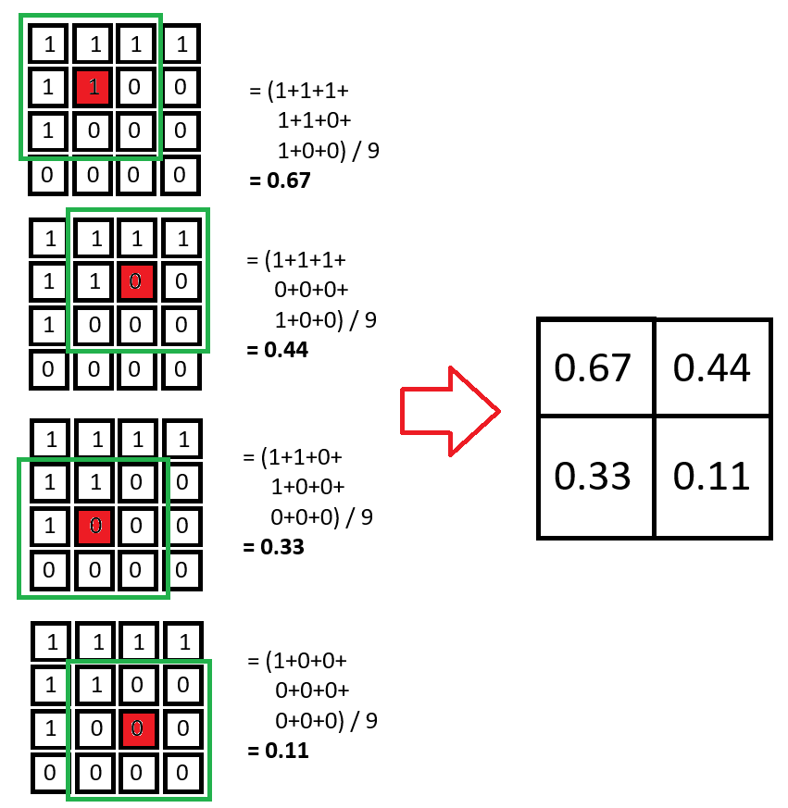

**Figure 1:** Example of an average filter convolution that achieves image blurring where the centre pixel is labelled red

### 

### Edge Detection

Edge detection is the process of detecting edges or continuous lines in an image and is used in:

1. Medical imaging to diagnose diseases more easily;

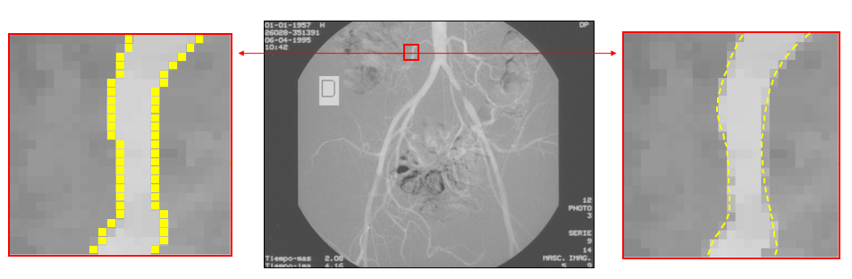

**Figure 2:** Edge detection on an angiographic image. [1]

1. Scene/image segmentation;

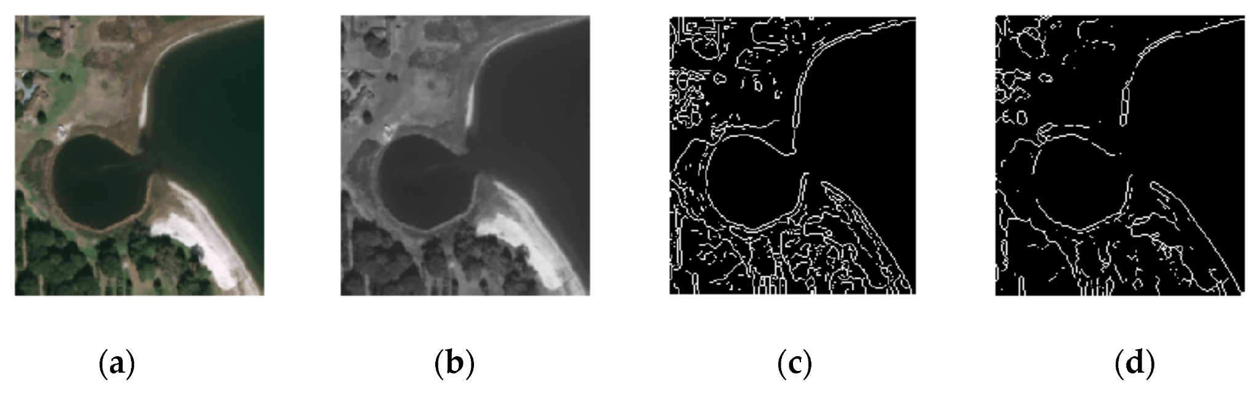

**Figure 3:** The region of a satellite image after edge detection [2]

1. Fingerprint recognition;

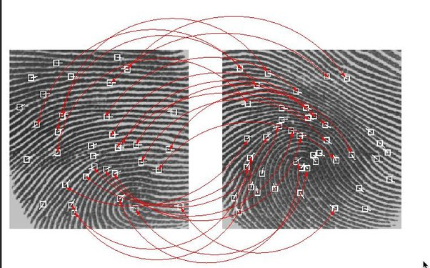

**Figure 4:** Fingerprint recognition using pattern matching from edge detection [3]

1. Satellite imaging;
2. and many more…

The purpose of detecting sharp changes in image brightness is to capture important events and changes in the properties of the world. Edge detection is one of the fundamental steps in image processing, image analysis, image pattern recognition, and computer vision techniques.

One method of performing edge detection would be to use [Sobel edge detection filters](https://en.wikipedia.org/wiki/Sobel_operator). These consist of filters in both the horizontal and vertical directions designed to detect edges in these directions. Sobel filters are shown below:

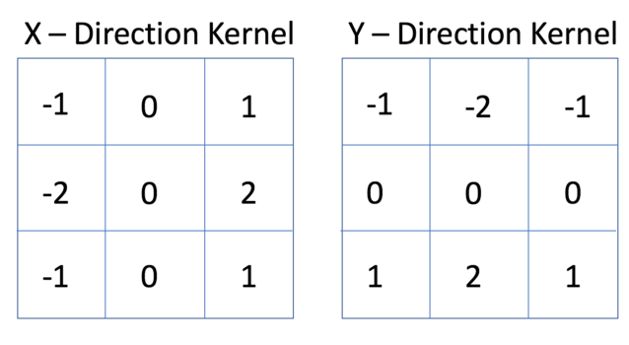

**Figure 5:** Sobel horizontal and vertical kernel filters

Example multiplication of your image with the X-Direction Kernel:

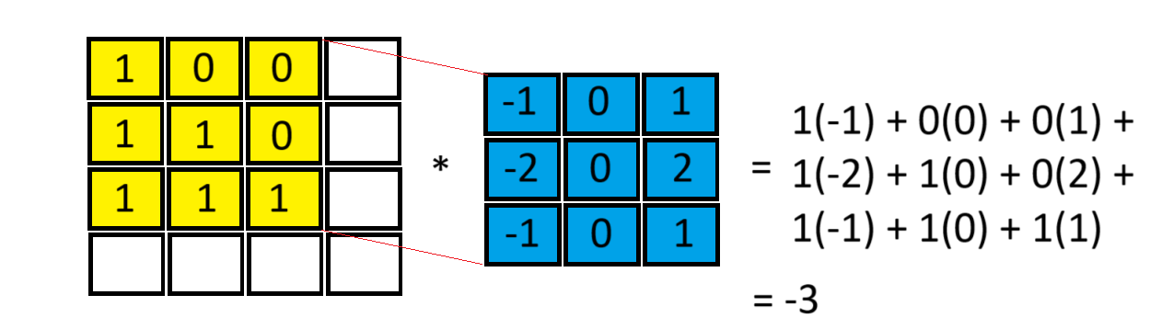

**Figure 6:** Example multiplication of a 3x3 image window with the 3x3 Sobel horizontal filter

## 

## **Git**

### Introduction to Git and GitHub

#### What is Git?

Git is a distributed version control system, designed to track changes in code and files efficiently. It allows multiple developers to work on the same project concurrently without overwriting each other's work. With Git, users can:

* Maintain a history of changes to files and revert to previous versions if desired.
* Work on different features simultaneously, using branches.
* Collaborate with others on separate features concurrently, through merging and rebasing.

#### What is GitHub?

GitHub is a cloud-based repository hosting service that enhances Git’s capabilities by providing additional tools and features for collaboration and project management. It enables you to:

* Store and share Git repositories in a centralised, cloud-based location
* Work collaboratively by managing contributions, tracking issues, and reviewing code changes
* Utilise additional features, such as issues, pull requests, and releases, which will be explained later in this document.

### Git Installation and Setup on Your Computer

#### Local Installation

If you are on Windows, you should install the [Git for Windows](https://gitforwindows.org/), which installs **Git Bash**, a terminal that allows you to use Git commands.

If you are on macOS, you can install Git using the Homebrew package manager:

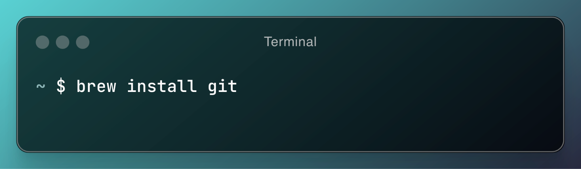

Additionally, there are some GUI-based tools, such as GitHub Desktop and GitKraken, which can simplify your Git workflows, however, they will not be covered in this document / supported by the teaching team. You are welcome to do your own research on these tools if you desire.

#### Create a GitHub account

Before you use GitHub, you need to create an account (if you do not already have one):

1. Go to the GitHub website: [www.github.com](http://www.github.com)
2. Sign Up:
   1. Enter a unique username
   2. Provide a valid email address (this should be your monash student email address)
   3. Choose a strong password
3. GitHub will send you a confirmation email. Click the link in the email to verify your account.

Once your account has been created, you can start creating repositories, collaborating on projects, etc.

#### 

#### Configuring Git

Once you have Git installed, you need to configure it with your user information. This information is used in commit metadata.

First, set your name and email address (this should be your monash student email address), using the following commands in the Git Bash terminal (if on windows), or the default system terminal (if on macOS):

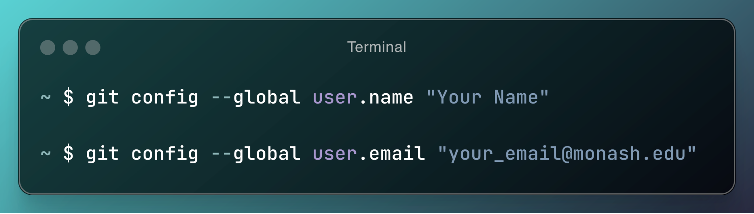

To verify these values have been set correctly, run the command git config --list, and check you can see your name and email address have been set correctly (the relevant lines in the command output have been highlighted):

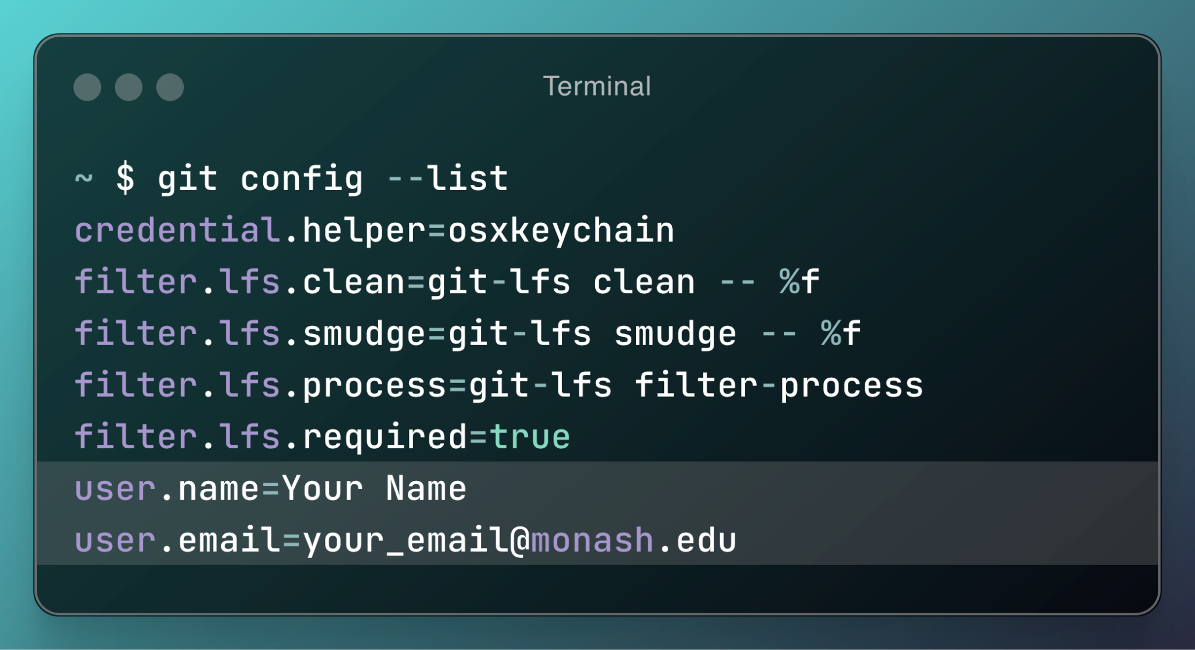

#### Generating and Adding SSH Keys

SSH keys allow secure authentication with remote repositories without needing to enter credentials repeatedly. They are effectively a “secret password” that you will keep on your local computer that allows you to commit to your GitHub repositories without needing to enter your username and password every time.

The process of adding SSH keys to your GitHub profile / your local computer will vary based on your operating system, so it is recommended that you follow the instructions provided on the official GitHub website, [here](https://docs.github.com/en/authentication/connecting-to-github-with-ssh/generating-a-new-ssh-key-and-adding-it-to-the-ssh-agent).

### Setting up a Git Repository

#### Creating a Repository on GitHub

To create a new repository on GitHub:

1. Go to [GitHub](http://www.github.com), and log into your account.
2. Click the “new” button (or go to [GitHub’s new repository page](https://github.com/new))
3. Enter your repository details:
   1. Choose a name for your repository. **For the ECE3073 project, you must name your repository according to the following pattern: ECE3073-Project2025-Group<Group number>**
   2. Add a description for the repository. This should be 1-3 short sentences that explain the purpose of the repository.
   3. Select the visibility of the repository. **For the ECE3073 project you must make the repository private. Failure to do so may result in disciplinary action**.
   4. Tick the “Add a README file” box. The readme file is a markdown file that introduces your project. This will be further explained later in this document.
   5. Do not add a .gitignore template. You will manually add this later in the repository setup.
4. Click “create repository”

#### Adding Collaborators

Once you have created a repository on GitHub, you can add collaborators, which will allow the users added to view and contribute to the repository.

**NOTE:** For the ECE3073 project, you **MUST** add the ece3073-monash github account as a contributor. Failure to do so may result in significant loss of marks.

To add collaborators:

1. Go to the repository on GitHub, and click settings.

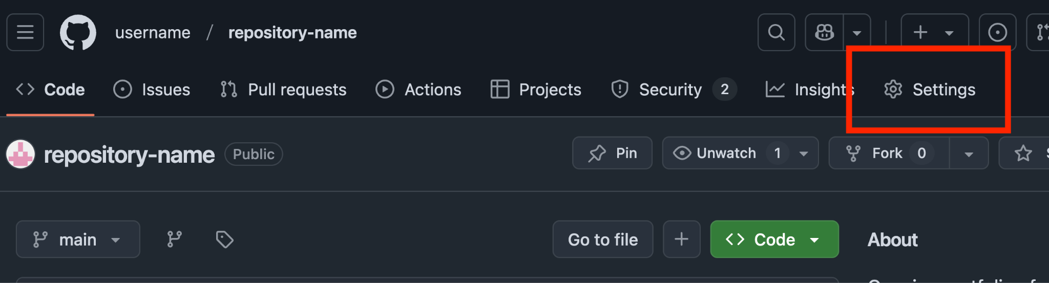

1. Go to the Access > Collaborators page on the left panel:

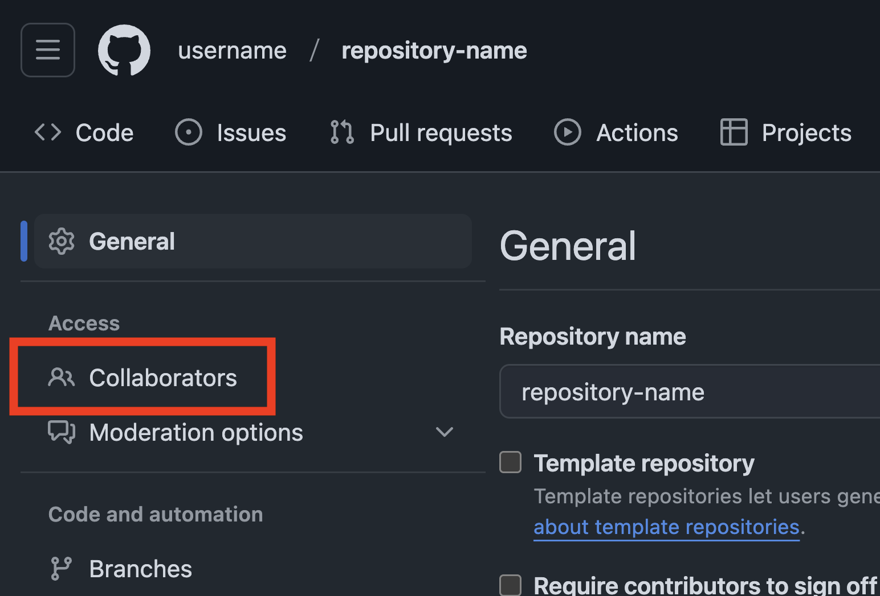

1. Click “Add people”, and search for your collaborators’ github usernames:

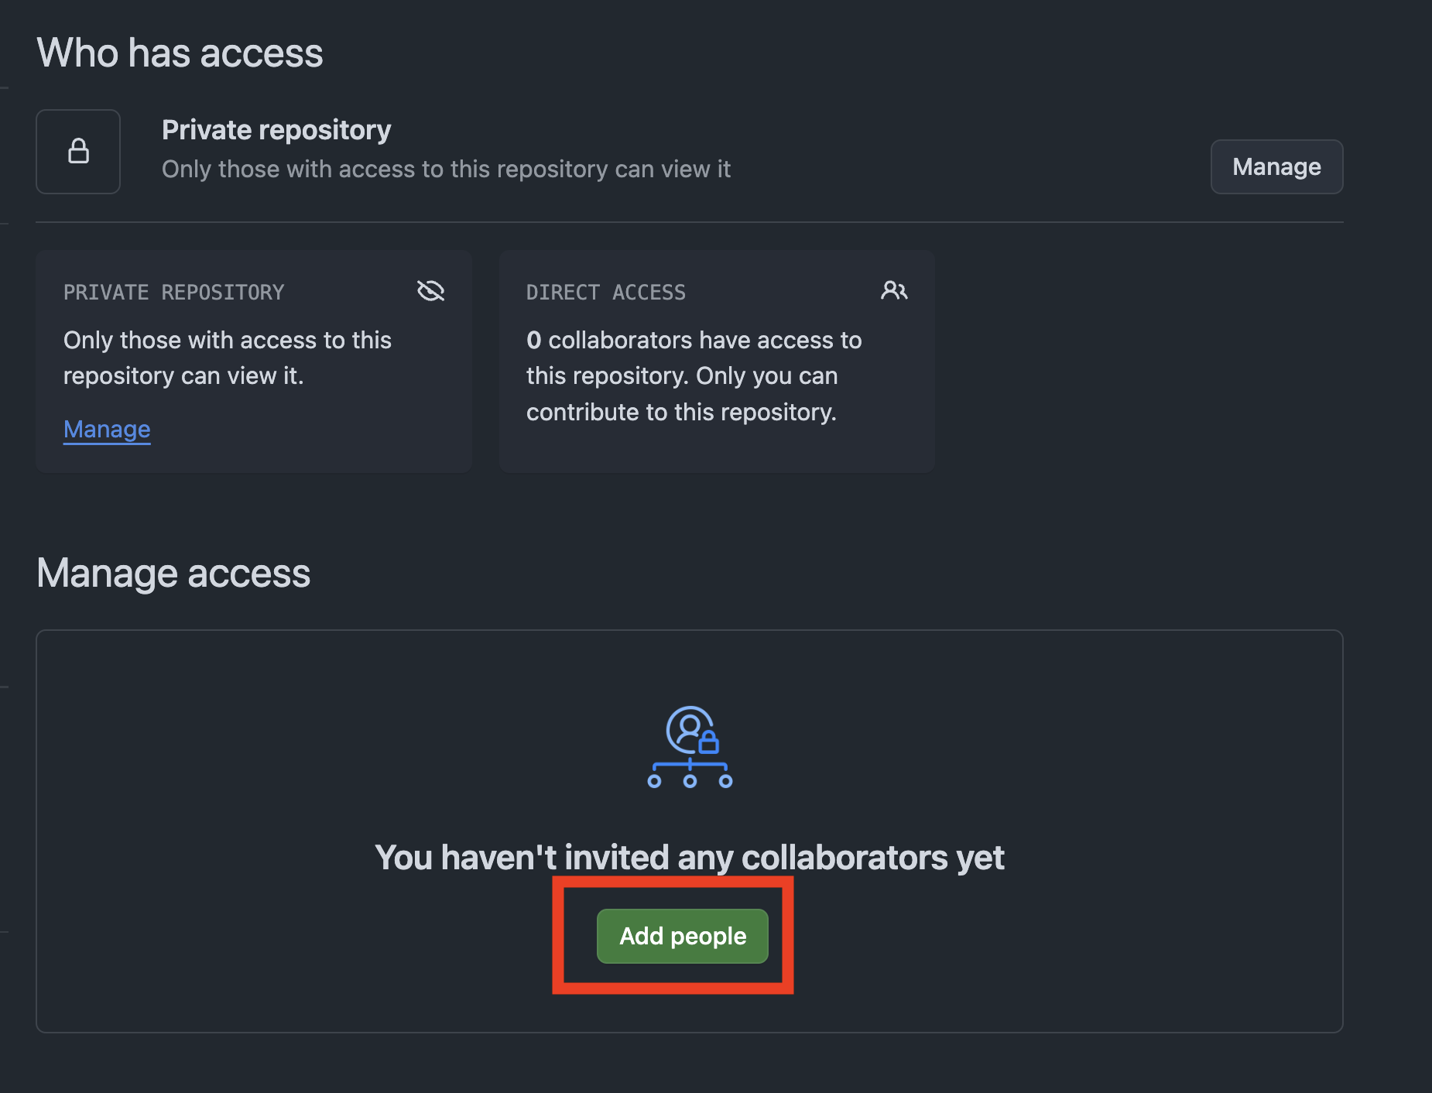

For example, adding ece3073-monash:

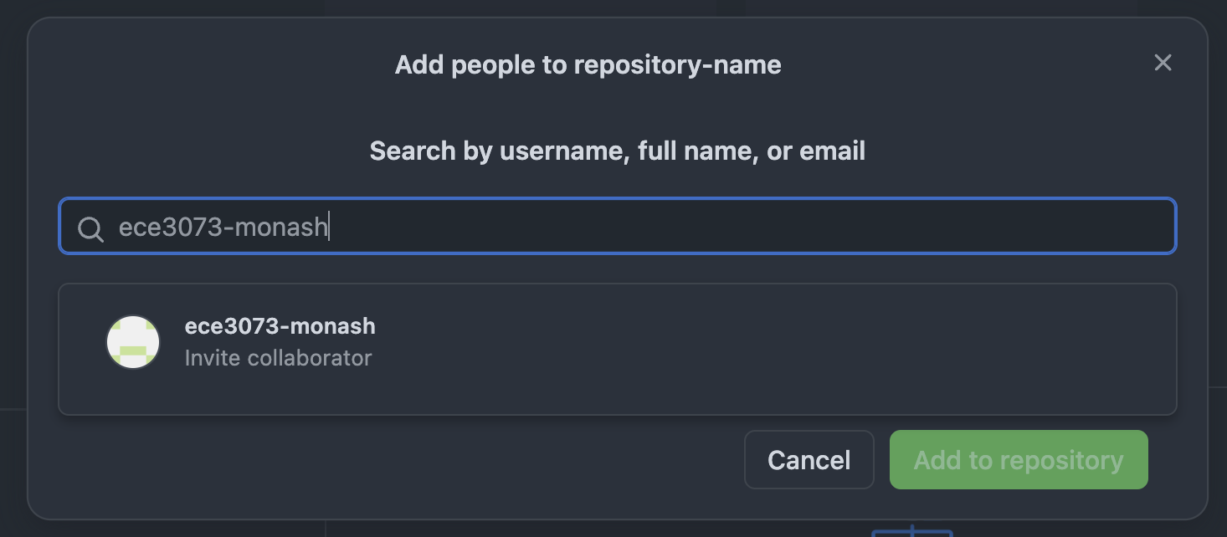

#### Cloning a GitHub Repository

Once you have created a repository on GitHub, you need to “clone” it to your local computer, so that you can use and modify the project.

To clone a repository, copy the repository URL. You can do this by clicking the green “<> Code” button on your repository, and copying the url that is displayed:

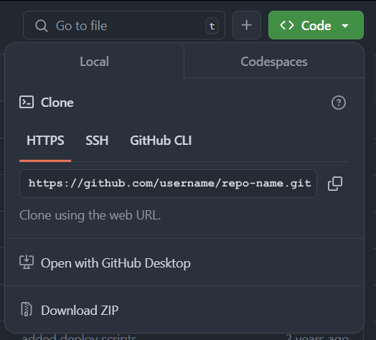

Next, in a terminal window that is in a directory that you can store your project in, use the command “git clone <url>”, as shown in the example below:

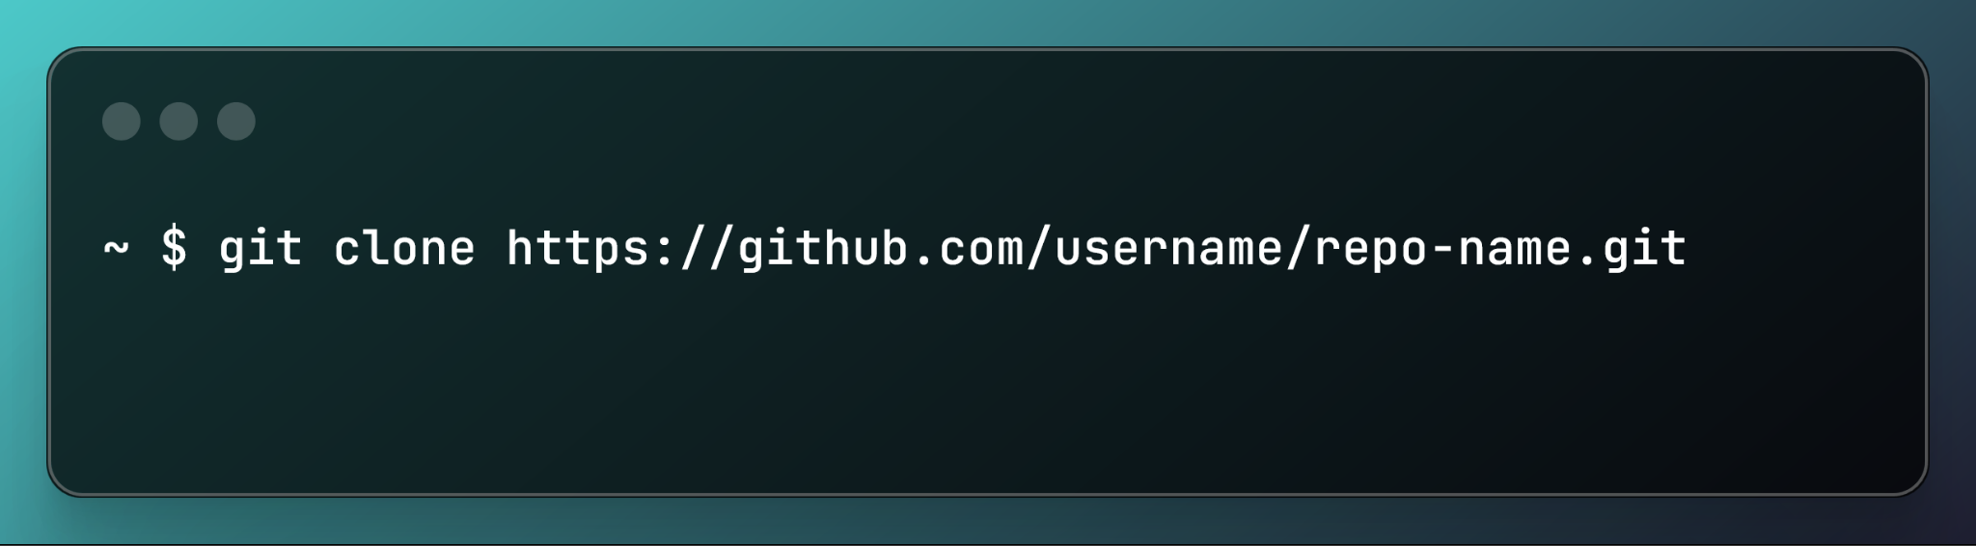

**Note**: since you have set up your SSH keys, the clone with SSH option will also work here.

#### Adding a Git Ignore

A .gitignore file tells Git which files and folders to ignore. This is useful for many purposes, such as ignoring temporary files and project build artifacts. This is because as long as the source code and core designs are in the repository, all users / contributors can re-compile the project themselves.

To use a git ignore file, simply create a file named .gitignore in the top level of your repository. Each line in this file contains a file or folder to ignore, and uses a regex-like syntax. For example, all files ending in “.log” can be ignored from the repository by including the line *.log in the gitignore file. The * acts as a wildcard, matching 0 or more of any characters. [This resource](https://gist.github.com/jstnlvns/ebaa046fae16543cc9efc7f24bcd0e31#git-ignore-patterns) provides a useful table of common gitignore patterns.

For Quartus projects, such as the ECE3073 project, we have provided a .gitignore template for you, linked [here](https://github.com/ece3073-monash/project-templates). If set up correctly, your remote repository should only contain two folders (one containing your NIOS-II system as generated by Platform Designers / Quartus, and one containing your Eclipse project) and file types *.v, *.qpf, *.qsf, and *.qsys.

### Basic Git Workflow

A basic Git workflow consists of a series of steps that help you track the changes in your project, collaborate with your group members, and ensure your project code/design is up to date.

#### Git Pull (Keep your repo up to date)

The git pull command fetches the latest changes from the remote repository (i.e., from GitHub.com), and merges the latest changes into your local repository:

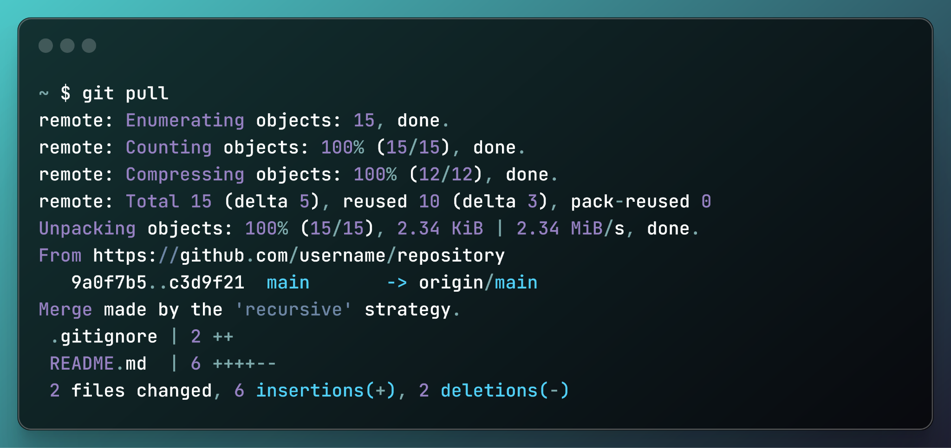

You should always pull the latest changes before making modifications to the project, to ensure you are always working on the most up-to-date version.

#### Making Changes and Committing

When you make changes to files in your local repository, Git tracks the changes that have been made since the last commit to the repo.

Before committing, you need to **stage** the changes. This tells Git which files you want to add in your next commit. To stage a specific file you can use the command git add <filename>. To stage all files, you can use the command git add ., which adds all changed files in the current working directory.

Once you have staged changes, you can view the files that have been staged using the command git status. This command displays files that have been modified but not staged, files that are staged and ready to commit, and untracked files that are not yet tracked by Git. For example:

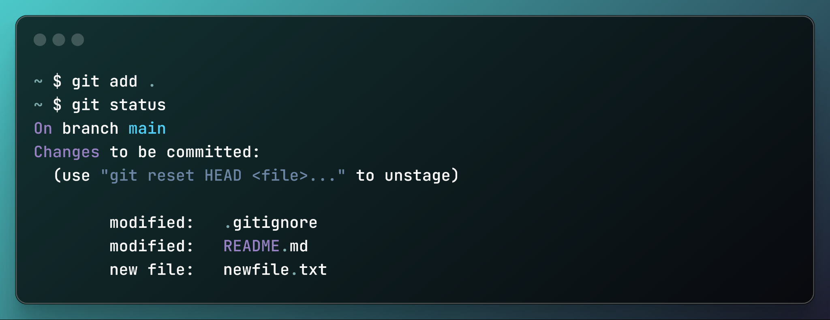

You can (and should) stage changes based on what you wish to have included in the current commit. This helps you organise your commits more effectively, and makes viewing the history of changes to the repo significantly easier.

Once changes are staged, use the git commit command to **commit** your changes. This adds all staged changes to the project’s history, along with a message. Your commit messages **must** be concise and descriptive of the staged changes.

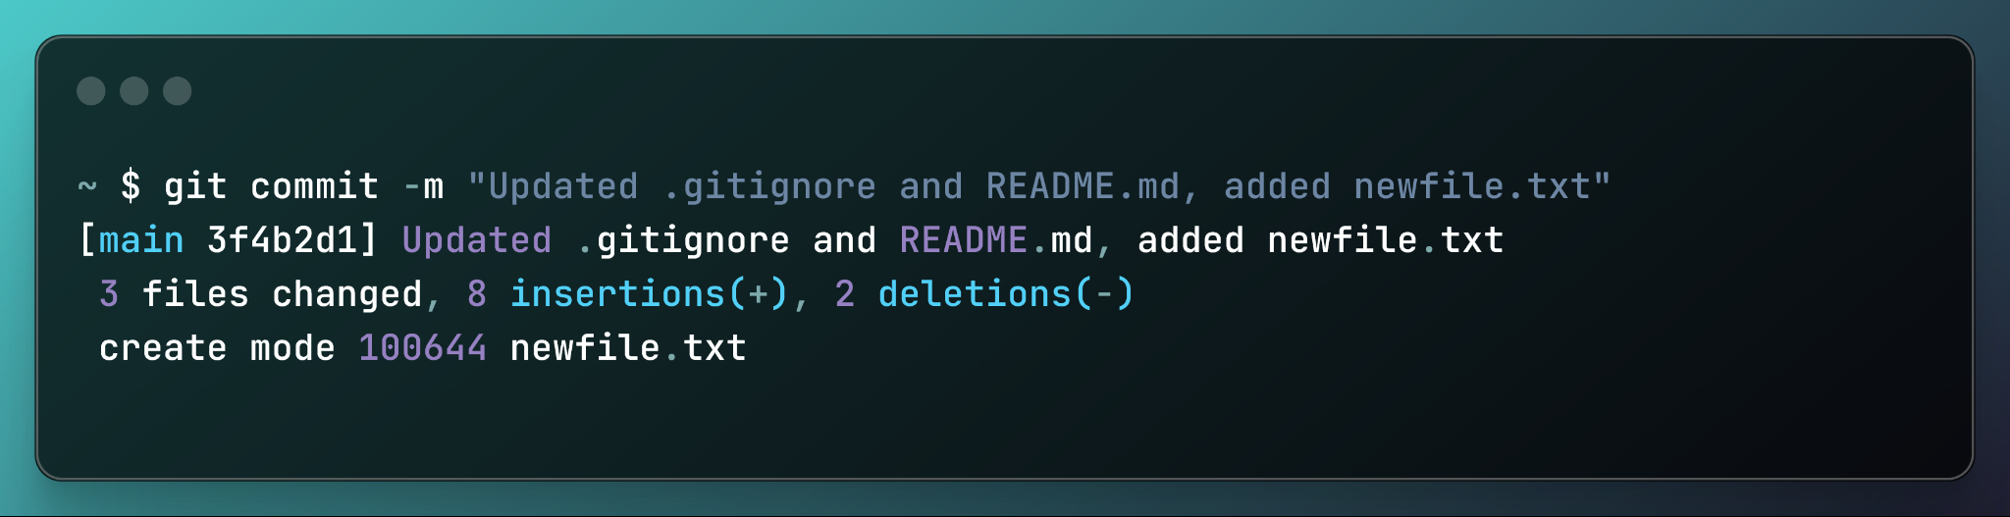

To make proper commit messages, you should consult [this resource](https://cbea.ms/git-commit/), but in summary, your Git commit messages should:

* Be approximately 50 characters or less
* Not end in a period
* Be written in imperative mood
  + I.e., “fix clock skew bug” rather than “fixed clock skew bug”
* Explain **what**, but not **how**, since it is used as a subject line or label for the commit

#### Viewing Commit History

The history of all commits can be viewed online on the GitHub repository site, or via the command line, using the command git log. This command shows the commit hashes (a unique ID for each commit), author name and email, commit message, and the timestamps for each commit. For example:

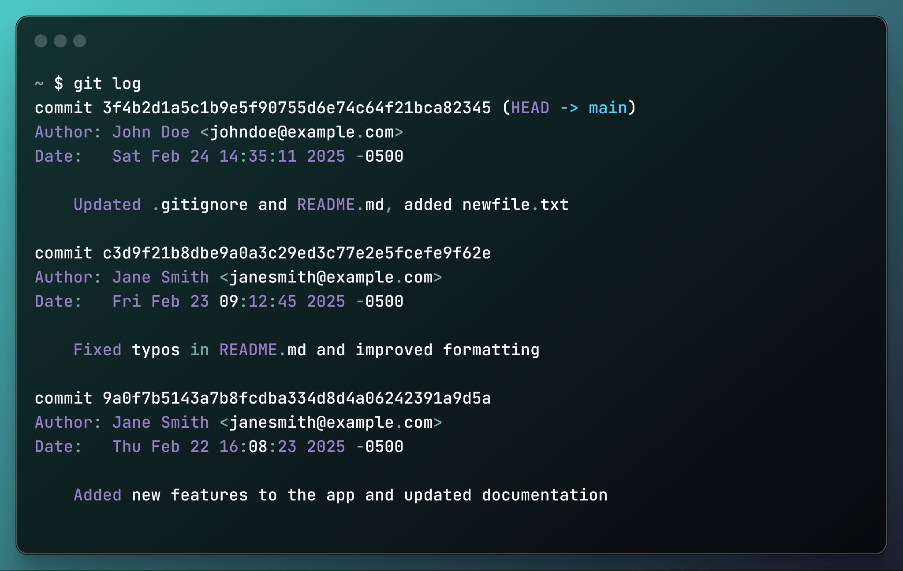

#### Keeping Your Repository Up To Date

You should regularly keep your repository up to date to prevent conflicts and keep your work in-sync and compatible with the other contributors.

You can:

* Pull the latest changes, using git pull
* Fetch the latest changes (without merging), which allows you to review changes before merging them, using git fetch, then merge the changes manually. Git fetch is also helpful to detect early conflicts between the remote branches and the copies in your local repository

### Branching and Merging

Branching in Git allows developers to work on new features, bug fixes, or experiments in isolation from the main codebase. Once changes are complete and tested, branches can be merged back into the main branch. This keeps the code in the main branch stable / functional, while still enabling progressive, parallel development.

#### Creating and Switching Branches

To create a new branch, use the git branch command.

To switch to a different branch, use the git checkout command.

For example:

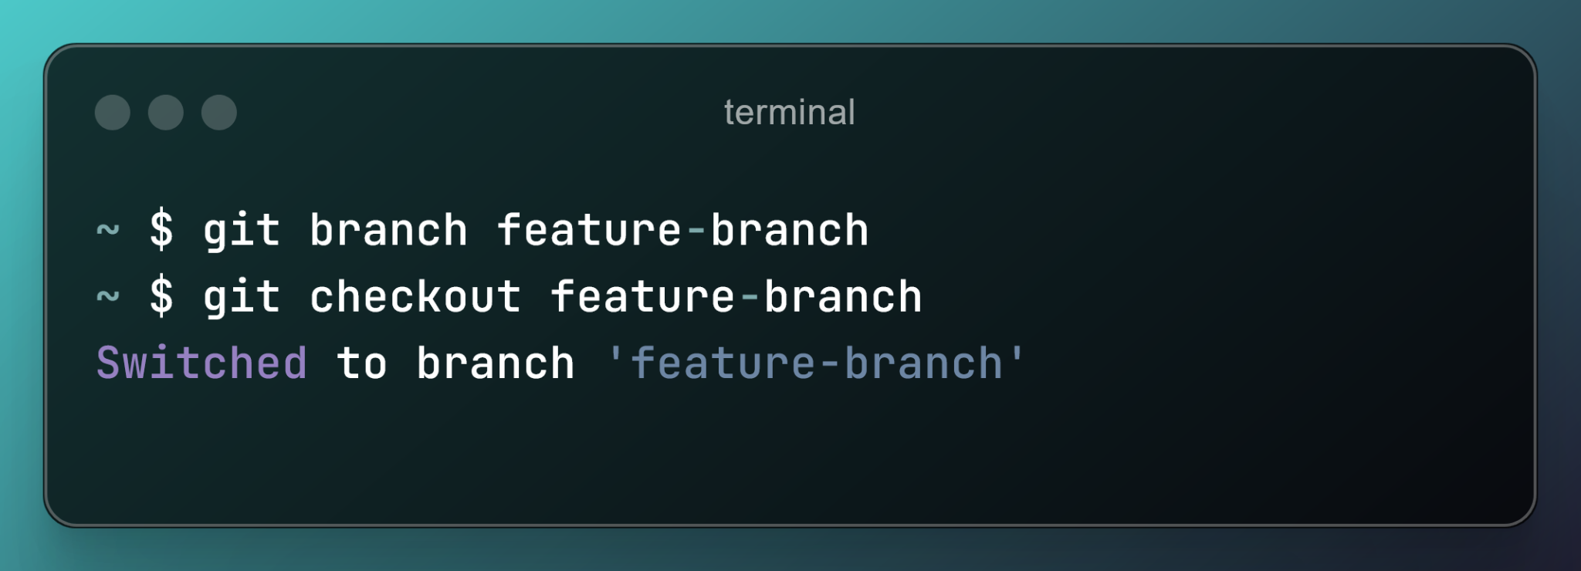

#### Merging a Branch into Main

Once work on the feature-branch is complete, it should be merged to the main branch (i.e., all of its changes should be applied to the main branch). To do this:

* Switch to the main branch
* Update your local main branch
* Merge the feature branch
* Push the updated main branch

**Note that for the purposes of the project, merges to the remote main branch will be done through pull requests and code reviews. You can refer to the sections below for details.**

If there are conflicts, you will have to resolve them yourself. You can refer to the section Handling Conflicts below for details.

This process can be seen below:

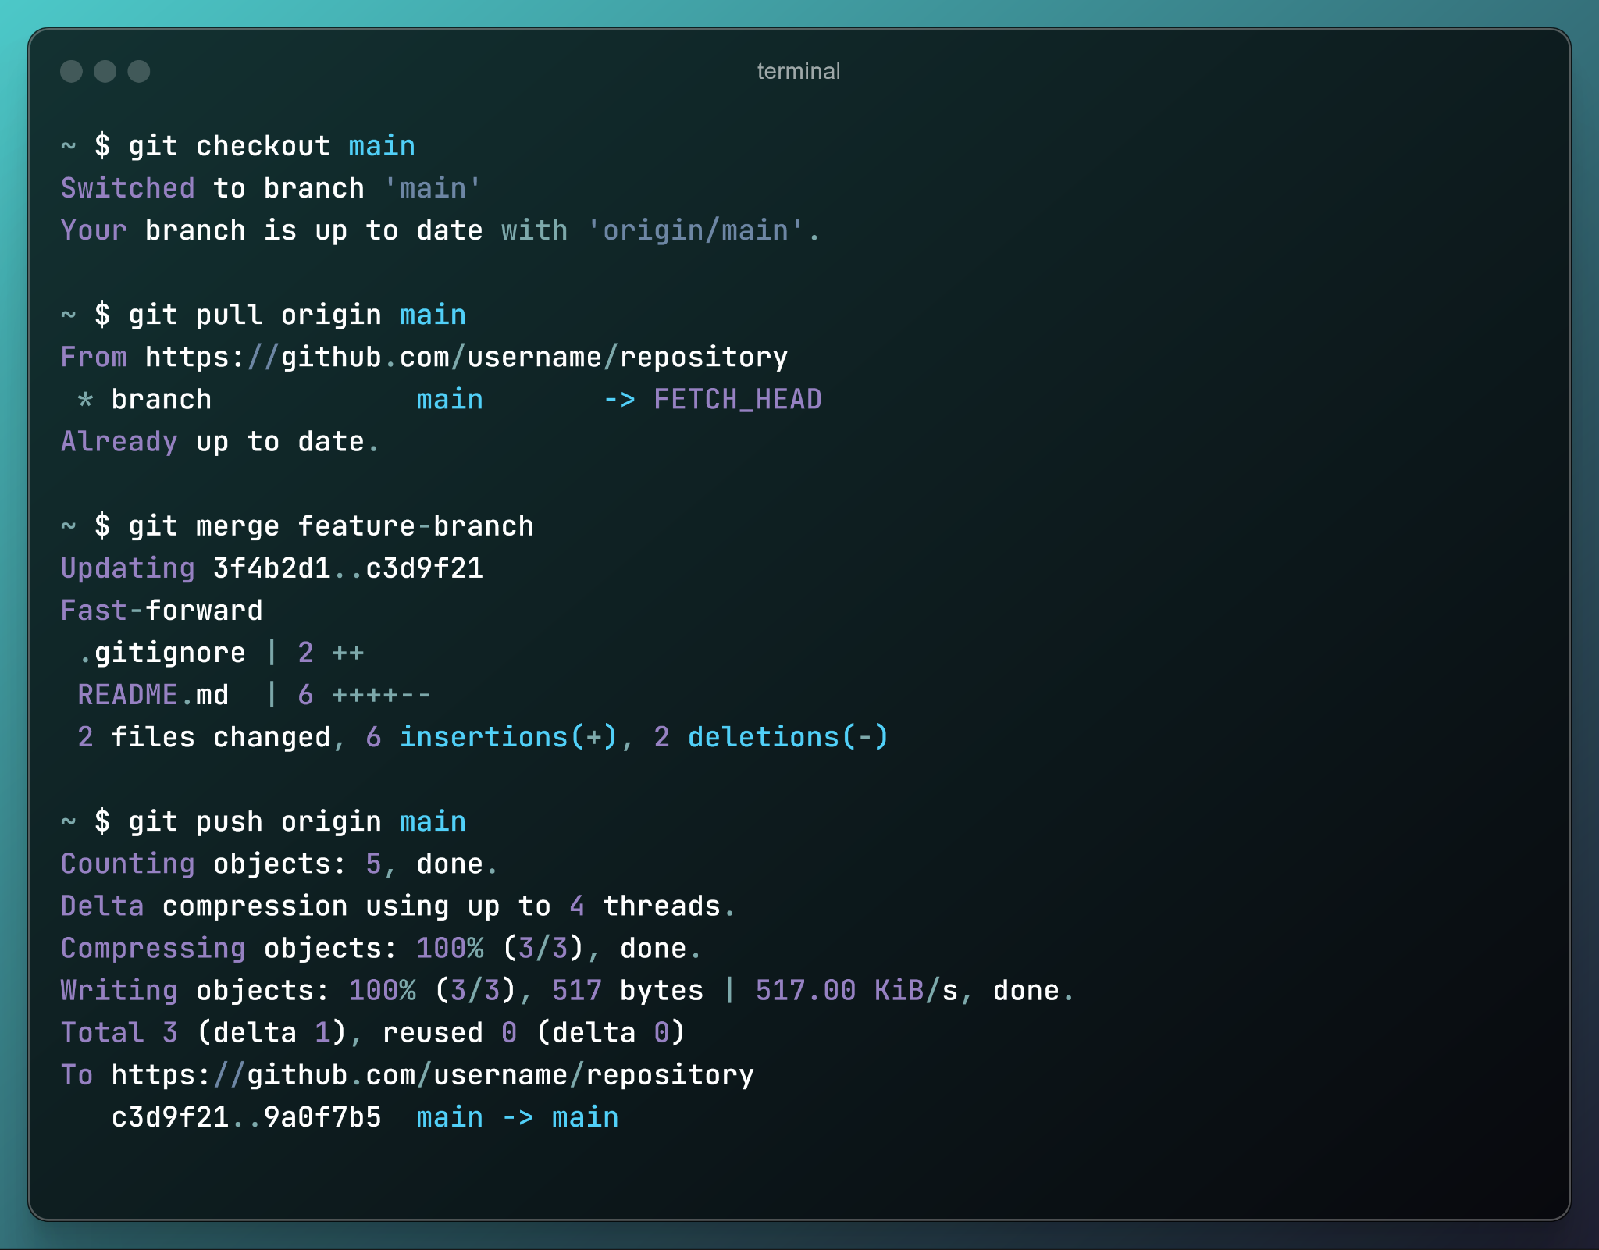

#### Deleting a Branch

**NOTE**: In real-world situations, you would delete the branch to ensure that the repository is kept clean, however for marking purposes, please do not delete any of the branches that you make in your project repository.

After merging, it’s good practice to delete the feature-branch, to keep the repository clean. The branch needs to be deleted from both the local repository, and the remote repository, which can be done using the following two commands respectively:

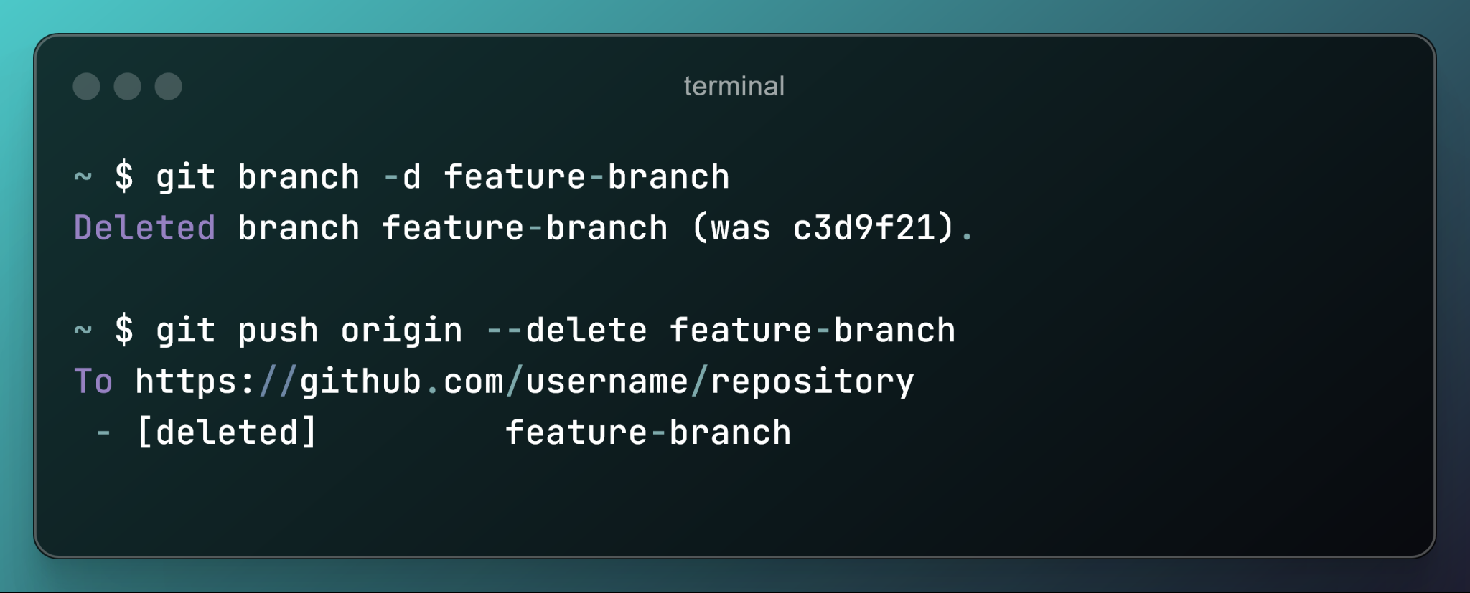

### The Feature Branch Workflow

The **Feature Branch Workflow** is a common Git workflow where each new feature is developed in its own branch, separate from the main branch. This prevents incomplete or experimental code from affecting the main branch, which should always contain a stable version of the project.

This methodology is often used in small to medium-sized teams or projects and focuses on isolating work on features or fixes. According to this methodology, your Git repo should be organised as follows:

* main **branch**: It contains a ‘production-ready’, deployable version of your project. Team members must ensure that their local main branch is up to date before creating a new branch to reduce the number of potential Git conflicts. You never commit directly to the main branch, only to other branches, and make pull requests to merge the feature branch with main.
* **Feature branches**: Short-lived branches for individual features or fixes and merged into main after the work is completed. It is possible to split the work required for completing a given task into smaller and manageable tasks that are easier to review and less likely to result in conflicts.

#### Branch Naming Conventions

When creating branches, it is important to use an appropriate, descriptive name for the branch so that others know what the branch is for / what changes it makes to the code/project. In this unit, we adopt a convention as follows (adapted from [this article](https://dev.to/varbsan/a-simplified-convention-for-naming-branches-and-commits-in-git-il4)):

category/description

Where **category** is one of:

* feature: for adding, refactoring, or removing a feature
* bugfix: for fixing a bug
* hotfix: for changing code with a temporary, quick solution without following a rigorous testing process, usually for emergency last minute changes
* test: for experimenting with things unrelated to the main goal(s)/trajectory of the project

The description should be a short explanation of the branch. It must be in kebab-case (all lower case letters, and spaces replaced by hyphens).

Some examples of branch names may include:

* feature/m2-accelerometer-integration
* feature/m3-rgb-data-rate-enhancement
* bugfix/m1-remove-vga-artifacts
* test/m2-accelerometer-tap-sense

#### Branch and Feature integration

Feature intergration is the process of incorporating completed features or changes from a feature branch into the main codebase (i.e. main branch). This involves merging the feature branch into the target branch through a pull request, resolving any conflicts, and ensuring the new functionality works correctly with the existing codebase.

The workflow steps are as follows:

In your **local repository**:

1. Create a feature branch
2. Work on the feature and commit changes regularly
3. Pull the latest changes from main regularly to stay up-to-date
4. Merge the branch onto main when the feature is complete

To integrate the changes into **remote** (GitHub)

1. Push the changes and open a pull request on GitHub
2. After the changes have been reviewed and approved by your teammates, merge the PR into the remote main code base

For more information on the feature branch workflow, please consult [this resource from Atlassian](https://www.atlassian.com/git/tutorials/comparing-workflows/feature-branch-workflow).

#### Pull Requests

A pull request is a proposal to merge a set of changes from one branch (e.g. a feature or fix branch) into another (e.g. main). They notify the development team that one feature has been completed and serve as a dedicated space to discuss the proposed changes. Through a pull request, collaborators can also review and approve the proposed set of changes before they are integrated into the main codebase.

A pull request can be created directly in Github once the new branch has been “pushed” into the remote repository. Make sure to clearly describe the functionality of the new feature/functionality and specify the team members that will review and approve the changes.

### Code Reviews

A code review is a systematic examination of changes (e.g. a feature branch) implemented by other team members to ensure quality, maintainability, and correctness before merging into the main codebase. It helps catch issues; enforce coding standards, guides, and best practices, and improve overall project quality through constructive feedback.

In this milestone, the code review process to employ with pull requests involves assigning two team members to the pull request. Each reviewer will then look at the change itself and assess

* + **Correctness**: Does the change function as expected?
  + **Readability**: Is the change clear and well-documented?
  + **Efficiency**: Are there unnecessary computations or inefficiencies?
  + **Coding Standards**: Does it follow team guidelines, coding guides and best practices?

Once reviewers complete their review, they can either mark it approved, block the review with change requests, or not set a specific status, leaving it in a “not yet approved” state. If changes are required, the reviewers can add comments, suggest improvements, and ask for clarifications directly in the pull request. If required, the author of the changes revises the code based on the feedback, making necessary changes and explaining any disagreements. Once all comments have been addressed and no further changes are required, the reviewers approve the changes and the branch can be merged into the main.

### Handling Conflicts

Conflicts are likely to happen when working in a team environment. Conflicts typically happen when two or more developers modify the same part of a file independently, and Git cannot determine which change should take precedence.

In the project, conflicts might arise when ‘syncing’ content from the remote repository into your local repository via the command git pull or when merging the feature branch into main. Below are the main steps to follow in case you encounter a merge conflict. **Keep in mind that these steps are taken on your local repository**.

* **Identify the conflict**: Git marks conflicting sections in the affected files with conflict markers (<<<<<<<, =======, >>>>>>>).
* **Edit the problematic file**: Manually review the conflicting sections and decide how to combine or choose between the changes. Common strategies when manually reviewing a conflict include:
* **Keep Both Changes**: Combine the changes from both branches or commits.
* **Choose One Change**: Decide which branch’s or commit’s changes to keep.
* **Rewrite the Code**: Write a new solution that incorporates the best of both changes.
* **Stage the resolved file**: Use git add <file> to mark the conflict as resolved.
* **Complete the merge**: Commit the resolved changes to finalise the merge process.
* **Recompile your project**: If the conflict occurred in your Platform Designer or Quartus files, make sure to re-generate your project in Platform Designer and then recompile on Quartus.

There are also a few strategies you can use to minimise the occurrence of conflicts. We note however that there is no “best strategy” and Git allows for a lot of flexibility on how to manage a repository:

* Planning can help reduce conflicts by ensuring team members coordinate their work effectively. For example, establishing a clear timeline for updates to the remote repository allows contributors to time their local changes strategically, minimizing overlap. Similarly, assigning specific files or modules to different team members can prevent conflicting modifications.
* Pulling with rebase can also help minimise conflicts by keeping the commit history linear (i.e. a straight, sequential flow of commits without unnecessary merge commits) and avoiding unnecessary merge commits. When you run git pull --rebase, Git applies your local changes on top of the latest remote changes instead of creating a new merge commit. **Important: rebasing is a common way to integrate upstream changes into your local repository and should never be used to rebase commits once they've been pushed to a public repository. If you are still new to Git, we recommend avoiding using rebase for M1 and M2, and focusing on the other suggested strategies.**
* Frequently checking the status of the main remote branch using git status and keeping your local main branch up to date can also help to minimise conflicts. Similarly, short and frequent changes and commits can also help minimise too-big and too-long-lived divergences between the remote main branch and your local repository.

#### Example Merging a Conflict:

This example has been simplified to illustrate the merging process, in reality you may need to handle conflicts in several files, however the overall process remains the same.

Imagine a repository has two branches, main and feature-branch, and both modify the same line in a file example.txt:

**main branch version**:

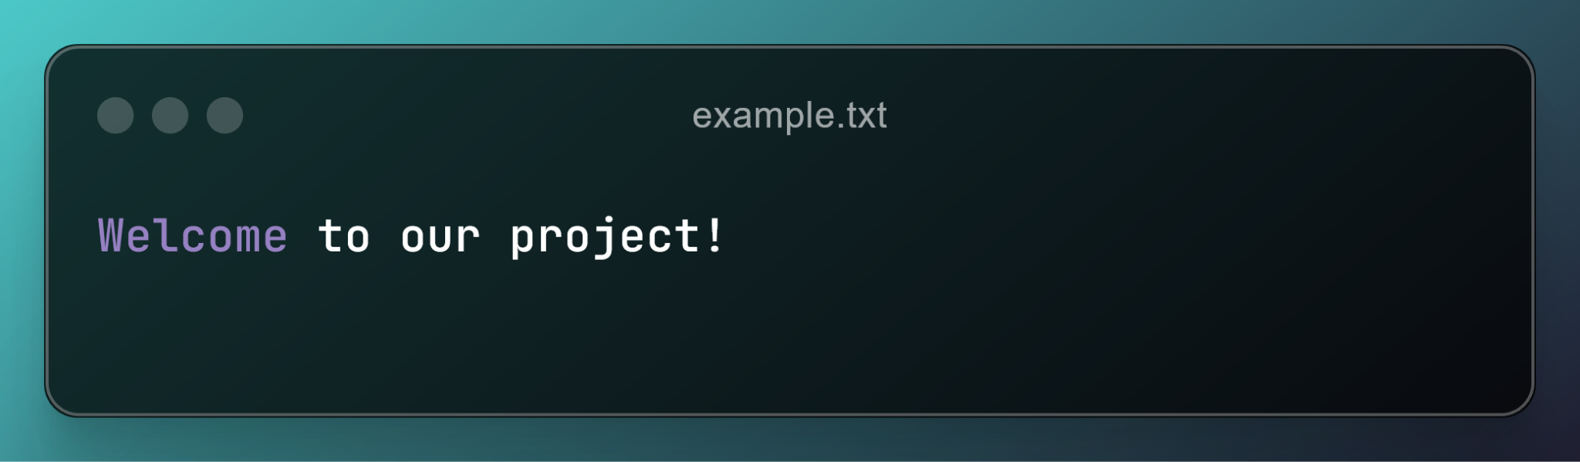

**feature-branch version**:

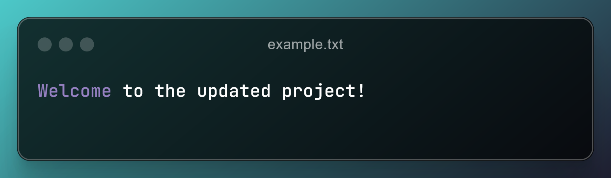

When attempting to merge these branches, Git will output a conflict message. Opening example.txt will show:

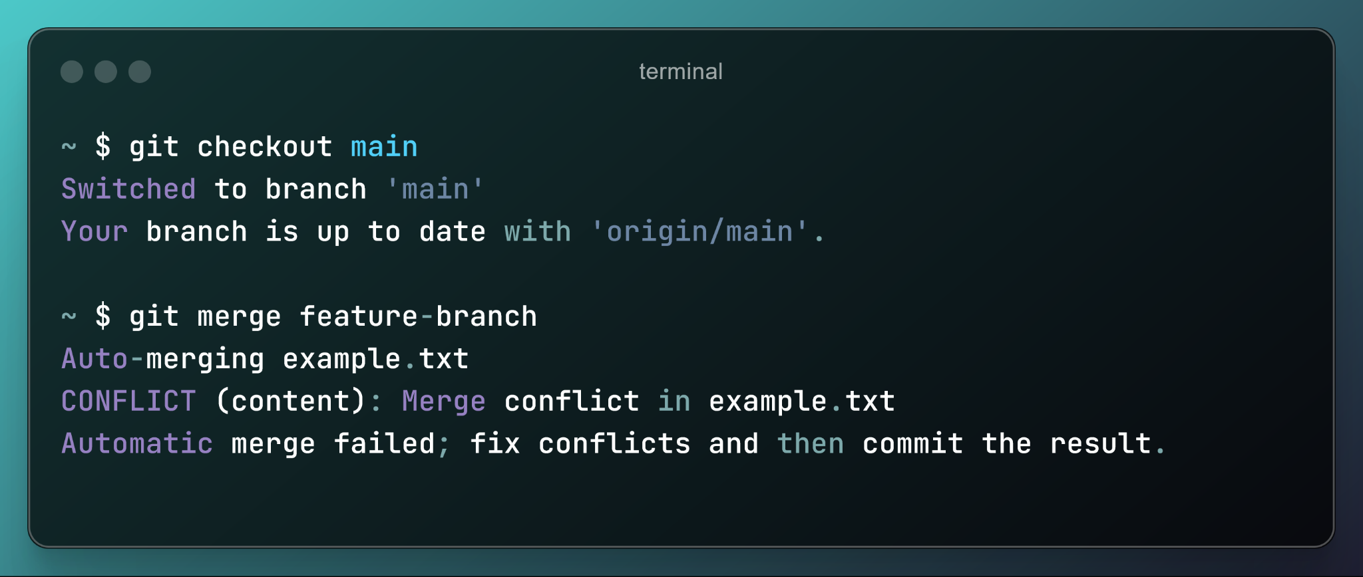

Opening example.txt will show the following:

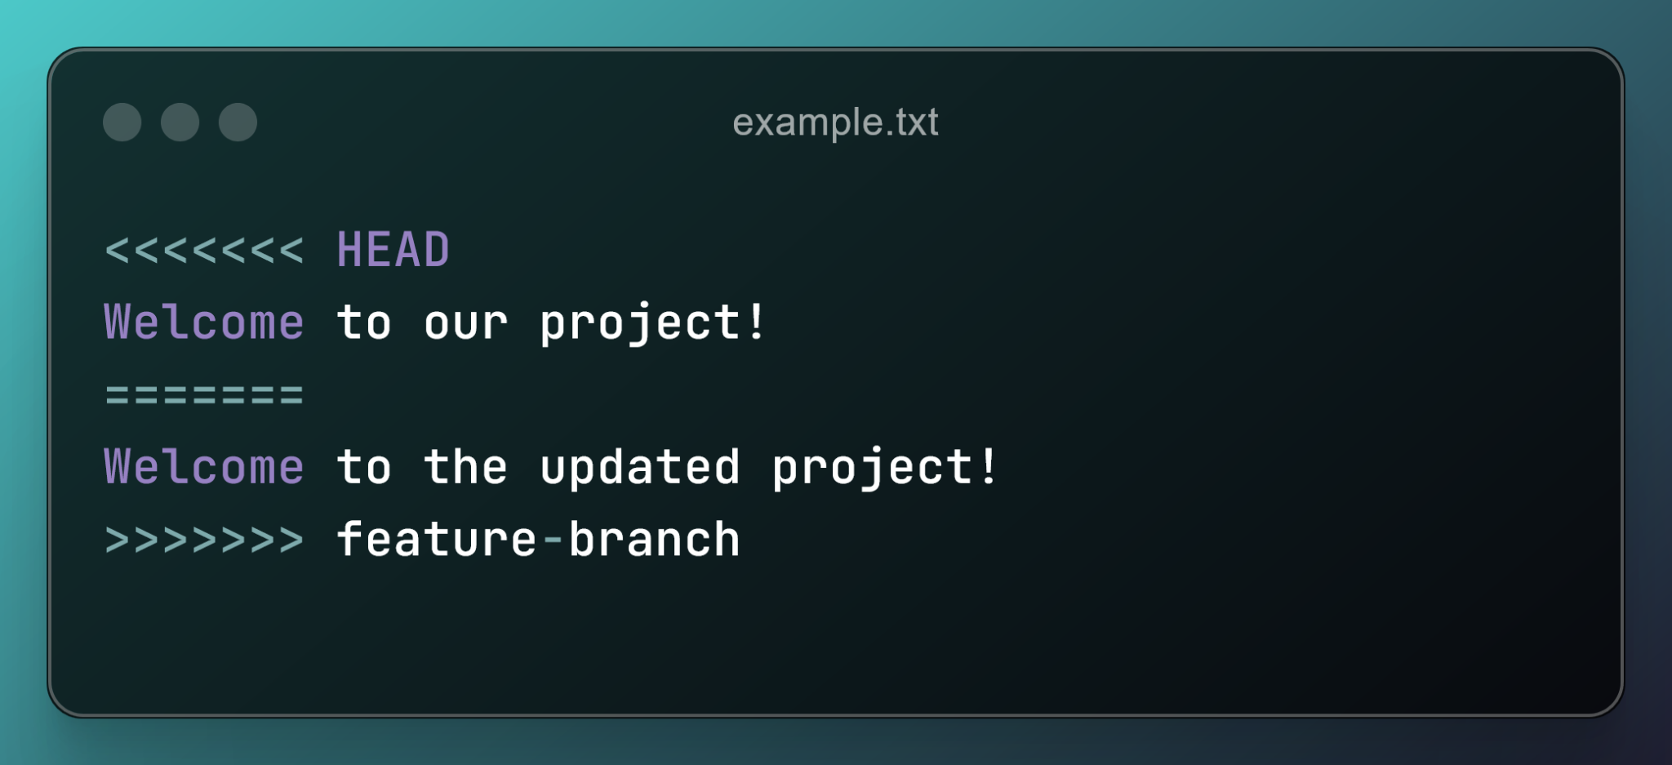

You must manually resolve the conflict by editing the example.txt file (note that opening the file in VS Code will provide a gui-based method to perform this conflict resolution). You will need to remove the conflict markers (the <<<<, ====, and >>>>) manually.

Finally, stage and commit the conflict resolution by committing like normal:

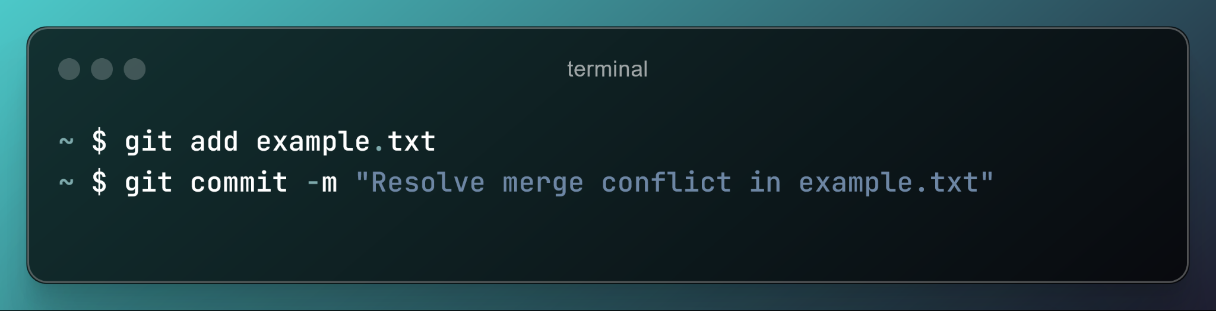

#### Tips for Avoiding Conflicts:

* Frequently pull changes from the remote repository
* Communicate with your team members when working on shared files
* Use smaller, focused commits (e.g., don’t rewrite the entire project and commit it in a single commit) to reduce the likelihood of conflicts

### Git Rebase

Rebasing is the process of moving or combining a sequence of commits to a new base (reference) commit. Rebasing as merging is used to integrate changes from one branch into another branch, however, rebasing *re-writes* the project history by creating brand new commits for each commit in the original branch. As such, when compared to merging, rebase results in a much cleaner project history. You will get familiar with rebasing in M3.

Rebasing is used in the following common use cases:

* To incorporate all of the new commits done in the main branch into your feature branch. This is particularly important before submitting a pull request
* Amending/revising a pull request to address the comments, questions, and suggestions resulting from a code review

### GitHub Features (Issues, releases, tags)

#### GitHub Issues

GitHub offers a built-in issue-tracking system to help teams manage tasks, track bugs, discuss new features, and document project progress. Once you have discussed and decided on a work plan with your team, you will create as many issues as required. Each issue must include a descriptive title, a short description that explains the purpose of the issue, a list of subtasks, and an assignee. Once completed/solved, an issue must be linked to the corresponding branch(es) and PR(s).

To create and manage issues:

1. Navigate to the “Issues” tab
2. Click “New Issue”
3. Provide a title and description, detailing the problem/feature request.
4. You should assign labels, milestones, and assignees.
5. Click “Submit new issue” to create the issue

#### Linking Issues to Pull Requests

When working on a fix or feature, reference the issue number in a pull request description to automatically close the issue when the pull request is merged.

#### GitHub Releases / Tags

GitHub releases allow you to package and distribute versions, providing release notes and changelogs.

To create a release:

1. Go to the “Releases” tab in your repository.
2. Click “Draft a new release”
3. Assign a tag (e.g., v1.0.0)
4. Provide a release title and description
5. Click “Publish release”

### README Files

A README.md file serves as the main documentation for a repository, helping users understand its purpose, setup, and usage.

#### Key Sections to Include in README:

1. Project name and description
2. Installation / Setup instructions
3. Usage Examples
4. License Information

### Further Resources

* MIT (2020). *Version Control (Git).* <https://missing.csail.mit.edu/2020/version-control/>
* GitHub (2025). *Git Cheat-Sheet* <https://education.github.com/git-cheat-sheet-education.pdf>
* Atlasian (2025). *Getting Git Right.* <https://www.atlassian.com/git>

1. For your own interest, [**this video**](https://youtu.be/3BJU2drrtCM?feature=shared&t=137) provides a good demonstration of this